Tour Report of Dr. J.P. Singh, Consultant, NMOOP on his tour to Jharkhand

This tour was undertaken from 15th to 18th November, 2016 to review the progress of implementation of NFSM, NMOOP, BGREI and to facilitate implementation of “Targeting Rice Fallow Areas (TRFA) for cultivation of pulses and oilseeds”, a sub-scheme of RKVY in district West Singhbhum.

2. Rainfall situation: Lower rainfall of 113 mm recorded in June, 2016 as against the average rainfall of 196.6 mm delayed the sowing of kharif crops. The normal rainfall of July, 2016 was followed with excess rainfall of 369.4 mm and 261.1 mm in August and September, 2016 against the normal rainfall of 276.2 mm and 235.5 mm respectively.

3. Prospects for Kharif crops : Paddy is a major Kharif crop with an area coverage of > 16 lakh ha followed by pulses (3.5 lakh ha.) and maize (2.8 lakh ha.). Kharif -2016 has been a good monsoon year for the State with an estimated record production of Kharif food grains of about 56 lakh tonnes comprising about 50 lakhs tonnes of paddy and 6.00 lakh tonnes of maize against the earlier highest production of 50 lakhs tonnes of Kharif food grains comprising about 47.00 lakh tonnes of paddy and 3 lakh tonnes of maize during Kharif 2011. Area and production of pulses also shows a positive trend. Harvesting of the maize and Kharif pulses except arhar is completed and harvesting of paddy is in progress in the State. The crop wise position of major kharif crops is given in Table – 1.

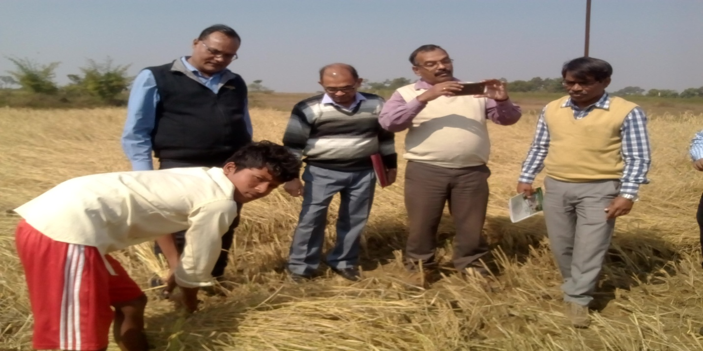

Harvesting of paddy

Table -1 : Area and Production of major Kharif Crops

(A=Area in lakh ha and P = Production in lakh tonnes)
Crop | Khrif-2011 |  | Kharif 2015 |  | Kharif 2016
 | A | P | A | P | A | P
Paddy | 14.69 | 46.96 | 15.89 | 24.71 | 16.79 | 49.88
Maize | 2.15 | 3.21 | 2.84 | 3.67 | 2.86 | 5.78
Pulses | 3.38 | 2.76 | 3.33 | 2.76 | 3.50 | 3.00
Oilseeds | 0.38 | 0.34 | 0.34 | 0.25 | 0.26 | 0.21
Total | 20.6 | 53.27 | 22.4 | 31.39 | 23.41 | 58.87
Note : Kharif pulses includes Arhar, Urd, Moong and Kulthi. Kharif oilseeds includes groundnut, sesamum and niger.

4. Prospects for Rabi – 2016-17: Major Rabi crops namely Mustard, Wheat and Gram are largely grown under rice fallows over an area of more than 5 lakh ha. depending upon the late kharif rains and moisture in paddy fallows. Other pulse crop like lentil & pea and oilseeds like linseed are also grown over a sizeable area of about 1 lakh ha during Rabi under Rice fallows. Thus, almost a million ha of area after rice remained fallow in Rabi season. Late kharif rains received in September/October, 2016 and availability of water in the ponds have brighten the prospects for Rabi 2016-17.

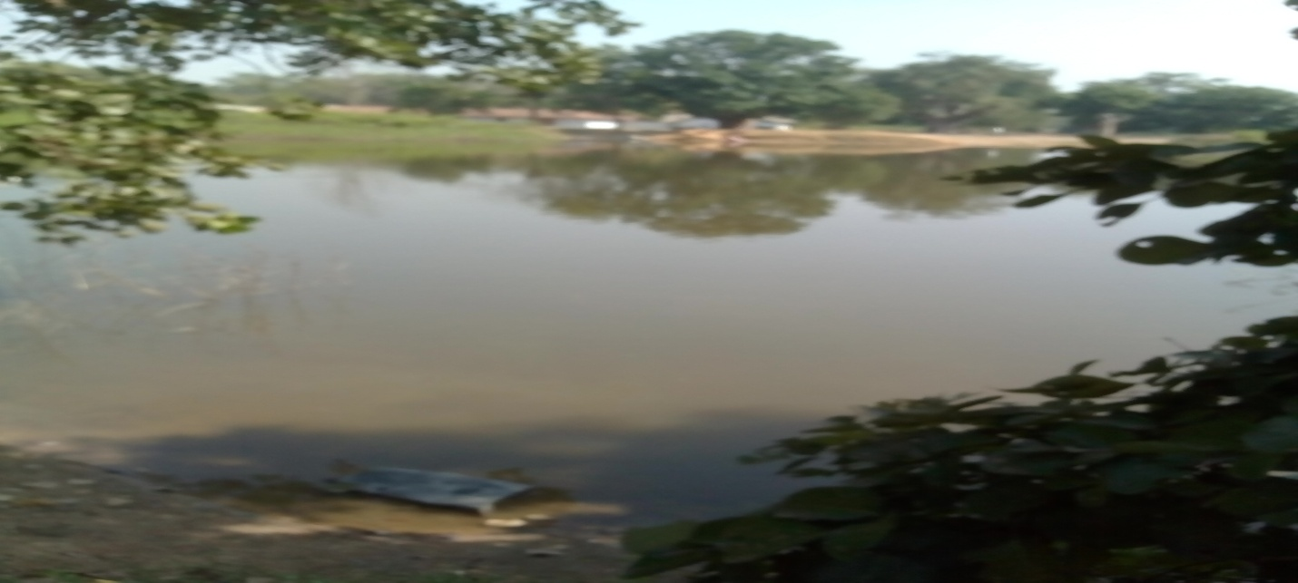

Availability of water for Rabi crop in district West Singhbhum

5. Additional area coverage under Rabi pulses/oilseeds in rice fallows: The state has prepared district wise action plan with enthusiastic targets for bringing an additional area of about 3 lakh ha of rice fallow under pulses (>1.50 lakh ha) and oilseeds (>1.50 lakh ha) during Rabi 2016-17. The Rabi season in Jharkhad is different from Gangetic plains, wherein sowings of Rabi-oilseeds and pulses is almost completed, whereas, sowings of these crops in Jharkhand normally start after harvest of paddy in the end of November and continue till mid of December. However, delayed sowing of Rabi-oilseeds particularly mustard and safflower have more chances of aphid infestation. In addition to a new scheme entitled, “Targetting Rice Fallow Areas for cultivation of pulses and oilseeds” , the State has also taken a number of initiatives like creation of water bodies, incentive for covering additional area of rice fallows with a target of one lakh ha and supply of seed drills with 100% subsidy. The area production of major rabi crop during last two years and targets fixed for Rabi- 2016-17 and expected additional area of > 3 lakh ha under Rabi pulses and oilseeds is given below in table – 2:

Table – 2 : Area and Production of Rabi Crops
(A=Area in lakh ha and P = Production in lakh tonnes)
Crop | Rabi – 2014-15 |  | Rabi 2015-16 |  | Target for Rabi 2016-17 (lakh ha) | Additional area (lakh ha)
 | Area | Production | Area | Production | Area | Production
Wheat | 1.71 | 3.30 | 1.61 | 2.74 | 2.41 | 0.75
Pulses | 2.49 | 2.77 | 2.49 | 2.57 | 4.01 | 1.52
Oilseeds | 2.31 | 1.50 | 2.26 | 1.52 | 3.95 | 1.67
Total | 6.51 | 7.57 | 6.36 | 6.83 | 10.37 | 3.94

District West Singhbhum has also prepared most enthusiastic targets for Rabi- 2016-17 with an increase of about three fold for pulses and oilseeds (Table – 3).

Table – 3 : Area and Production of Rabi Crops
(A=Area in ha and P = Production in tonnes)
Crop | Rabi – 2014-15 | Rabi 2015-16 | Target for Rabi 2016-17 (lakh ha) | Additional area (lakh ha)
 | Area | Area | Area | Production
Wheat | 2595 | 1515 | 7500 | 5445
Pulses | 7833 | 5633 | 18400 | 11667
Oilseeds | 6807 | 4206 | 27500 | 21993
Total | 17235 | 11354 | 53400 | 39105

6 Monitoring of strategic interventions:

6.1 Availability and supply of seeds for Rabi 2016-17: State is yet to establish a Seed Corporation and therefore, largely depend on supply of seed by NSC and Private Sector. Crops and variety wise action plans prepared by the State for supply of seeds for Rabi crops is given below in Table-4:

Table-4: Details of seed availability / requirement

Crop | Varieties | Qty. in qtl. | Scheme | Rate of assistance
Wheat | K-307, PBW-343, HUW-234, DBW-17,HD-2967, HI-1563 | 26002 | Seed Exchange and distribution | 50%
 | DBW-17, HD-2967 | 28117 | BGREI | 50%
 | DBW-17, HD-2967 | 15625 | BGREI | 100%*
Mustard | PM-26,PM-30, PUSA Bold | 3795 | Seed Exchange and distribution | 50%
 | PM-30 | 76.85 | NMOOP | 100%*
Gram | Pusa – 256, Pusa – 372 | 800 | Seed Exchange and distribution | 50%
Lentil | DPL-62, K-75 | 2873 | Seed Exchange and distribution | 50%
 | WBL-77 | 180 | NFSM | 100%*
Pea | HUDP-15 | 1500 | Seed Exchange and distribution | 50%
*Note: 100% assistance under demonstration components of NFSM, NMOOP and BGREI.

During the discussions held with DAO, PD, ATMA and PC, KVK, West Singhbhum, it was informed that NSC has shown inability to supply the committed quantities of seeds of varieties of pulses and oilseeds listed in the above statement. However, KVK West Singhbhum has agreed to supply seed of short duration varieties namely Pusa-28(50 kg) and Pusa – 30 (100 kg) of mustard to DAO for organizing cluster demonstrations under TRFA. The availability of seed of pulses and oilseeds varieties was also enquired from market and it was gathered that the seeds of popular varieties like Pusa Bold of mustard, T-397 of linseed, BG-372 and K-75 of lentil, which are >15 years old is available in the market. Therefore, DAO, West Singhbhum has requested DA, Jharkhand for seeking age relaxation of varieties of oilseeds and pulses from DAC & FW (Annexure-I). Director Agriculture vide his letter dated 23.11.2016 has accordingly sought age relaxation for pulses and oilseed varieties(Annexure-II).

6.2. Supply of seed minikits

Seed minikits of black gram (250) and green gram (200) were supplied during kharif-2016 in West Singhbhum district. Crop has already been harvested and yield data is being collected and compiled. The farmers have appreciated the good performance of variety. Status of allocation and supply of seed minikits of pulses and oilseeds in Jharkhand state during rabi-2016-17 is given below in Table 5:

Table-5: Allocation and supply of seed minikits for rabi 2016-17:

Crop | Variety | No. of seed minikits |  | Date of supply
 |  | Allocated | Supplied by NSC
Gram | JAKI-9218 | 10,000 | 3,550 | By 9.11.2016
Urd | PU-31 | 500 | 50 | By 9.11.2016
Mustard | PM-30 | 15,000 | 15,000 | By 27.10.2016
 | RGN-236 | 5,175 | Nil | -
Total |  | 30,675 | 18,600

6.3. Seed production:

Implementation of Seed Village Programme through Birsa Agricultural University (BAU) including KVKs is a good initiative taken by the state. The progress of seed production programme undertaken by BAU during kharif-2016 and proposed for rabi-2016-17 including Pulses Seed Hub was discussed with Director, Seeds and Farm, BAU, Ranchi on 16.11.2016 and Programme Coordinator, KVK, Jaganathpur, West Singhbhum on 17.11.2016. The progress is summarized is as under:

6.3.1. Seed production programme at BAU, Ranchi:

BAU has a seed farm with a cultivated area of >400 ha in Ranchi and Hazaribagh Campus. Ranchi campus has an area of about 60 ha and 10 water bodies created with grant-in-aid provided under RKVY by the State Government. All these water bodies have adequate water for organizing foundation/certified seed production of pulses and oilseeds during Rabi-2016-17.

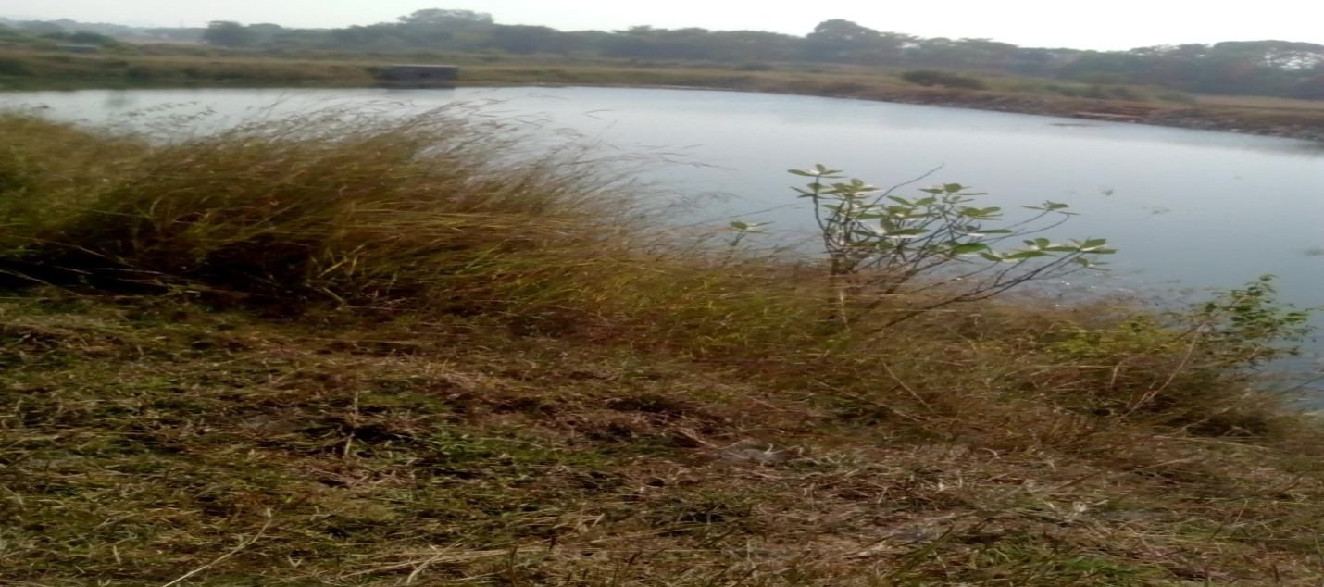

Availability of water for Rabi crops at BAU Seed Farm

Large scale seed production of paddy over an area of 25 ha with varieties Abhishek (10 ha), Shahbhagi (4 ha) and IR-64 (2 ha), a drought resistant variety released during 2015 and also recommended for cultivation in Jharkhand State has been organized at Ranchi farm during Kharif-2016. In addition, foundation seed production of NDA-2 variety of Arhar (1 ha) and Birsa Niger-2 of Niger (0.5 ha) have also been organized on the University Farm. The seed plot of paddy, arhar and niger without any off type plant indicates high degree of purity in seed being produced by the University.

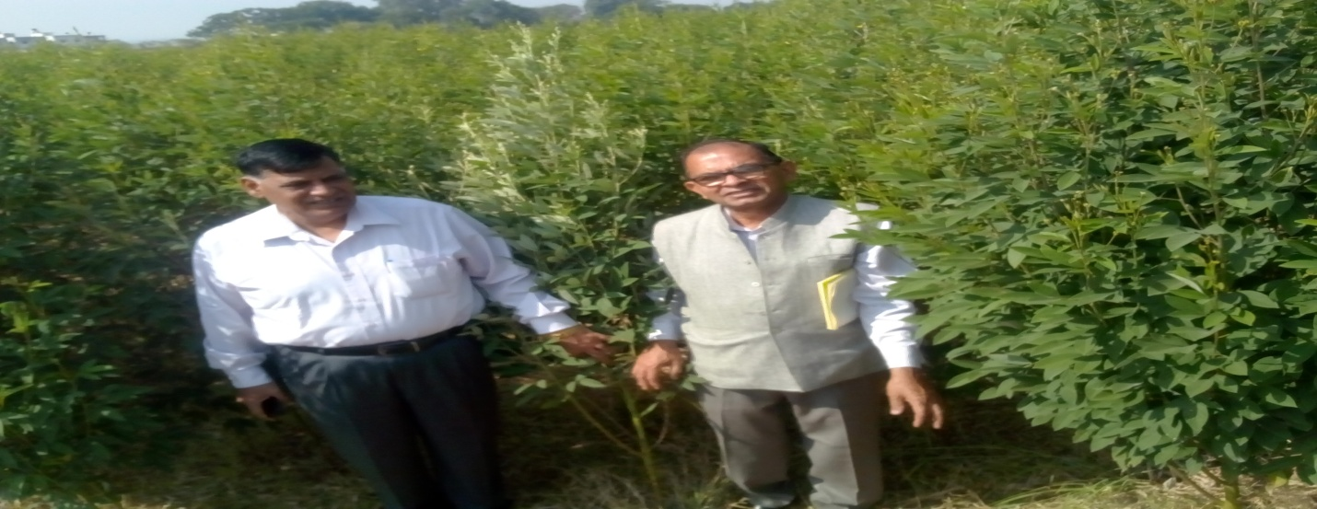

Seed plot of Arhar- NDA-2 at BAU Farm

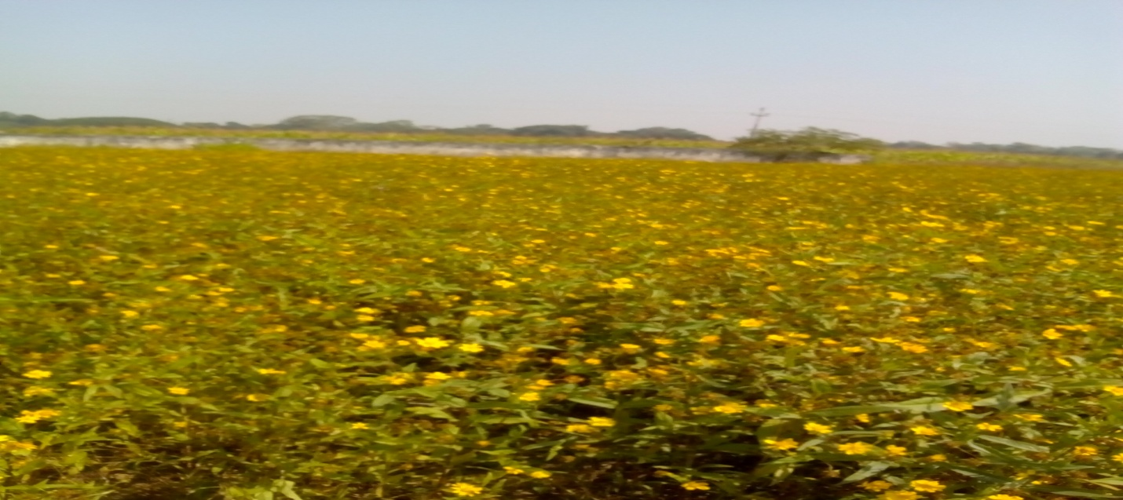

Seed plot of Niger- Birsa Niger-2 at BAU Farm

6.3.2. Pulses Seed Hub:

The administrative approval issued by the Crop Division includes location of seed hub as KVK, East Singhbhum, BAU, Ranchi, whereas, Director, Seeds and Farm, BAU, Ranchi has informed about the involvement of 2 KVKs namely Dumka and Bokaro and 2 ZRS Chianki and Darisai. He has also informed that change of location has already been intimated to DAC&FW. An area of 68.5 ha was covered under foundation/certified seed production of pulses during Kharif 2016 and as against the target of 500 qtls., production of 605 qtls. FS/CS is expected. The centre-wise details is given below in Table-6:

Table-6: Details of pulses seed hub:

Name of Seed Hub Centre | Variety | Area in ha. | Expected production
 |  |  | Qty. in quintal | Class of seed
Pigeon pea (Arhar)
ZRS, Chianki | Bahar | 8.0 | 80.00 | Certified
ZRI, Darisai | Birsa Arhar-1 | 1.5 | 15.00 | Certified
KVK, Dumka | NDA-2 | 20.0 | 200.00 | Foundation
KVK, Bokaro | NDA-2 | 23.0 | 230.00 | Foundation
Black gram (Urd)
ZRS, Chianki | WBU-109 | 7.00 | 35.00 | Foundation
ZRI, Darisai | WBU-109 | 1.00 | 5.00 | Foundation
KVK, Bokaro | WBU-109 | 8.00 | 40.00 | Foundation
Total |  | 68.50 | 605.00
Breeder seed of >150 qtl. of gram (110 qtl.), Field Pea (40 qtl) and Lentil (2 qtl) is available with BAU for Rabi season and these crops will be sown after harvest of paddy crop.

6.3.3. Seed Village Programme of KVK, Jaganathpur:

Details of crop and variety-wise seed production programme organized by KVK during kharif-2016 and proposed for rabi-2016-17 is given in Table-7.

Table: 7. Details of Seed Village Programme

Crop | Variety | Area in ha | Estimated production | Class of seed
Paddy | Sahabhagi | 49.00 | 800.00 | Certified
Soybean | JS-97-52 | 0.10 | 0.50 | Foundation
Urd | PU-31 | 3.00 | 15.00 | Certified
Wheat | K-9107 | 5.00 | 100.00 | Certified
Mustard | JD-6 | 10.00 | 100.00 | Certified
Linseed | BAU-06-03/T-397 | 10.00 | 50.00 | Certified

6.3.4. Cluster demonstration by SDA:

Cluster demonstration of inter-cropping of arhar variety Malviya-13 with maize hybrid HQPM-1 organized by the State Department of Agriculture in village Chota Kunti, Block Kumardungi was visited. Sh. Gulshan Hembram (ST) informed that he has sold maize cobs and earned a sum of Rs.80,000 out of his field of 1 ha. He is also expecting an yield of >5 qtl. of arhar, which is at flowering at pod formation stage. One field of another innovative famerSh.Rasika Pingua(ST)was visited in village Todapi. The farmers has started an integrating farming comprising cultivation of cucarbits/vegetables, dairy, fisheries, poultry, pigries and vermin-cum-posting. He has laid drip and poly mulch over an area of about 3 ha. Watermelon was cultivated during last winter season with drip and poly mulch with high economic return of >Rs. 1 lakh per ha and field pea has now been grown under same poly mulch and drip system for vegetable purpose.

Demonstration sesame variety RT 346 and Niger variety Birsa Niger -2 have been organized poor and area of 100 and 180 hectare respectively in the districts under state plan. Under this demonstration seed, PSB, phospho Gypsom, Borex, weedicied and vermicompsed were supplied to the beneficiary farmers. Four Niger plots of S/S Ramesh Triya, Raoto Triya, Jagdish Triya and Sushila Triya were visited. All these farmers are tribal. These farmers have confirmed about the receipt of inputs but crop condition was not very encouraging.
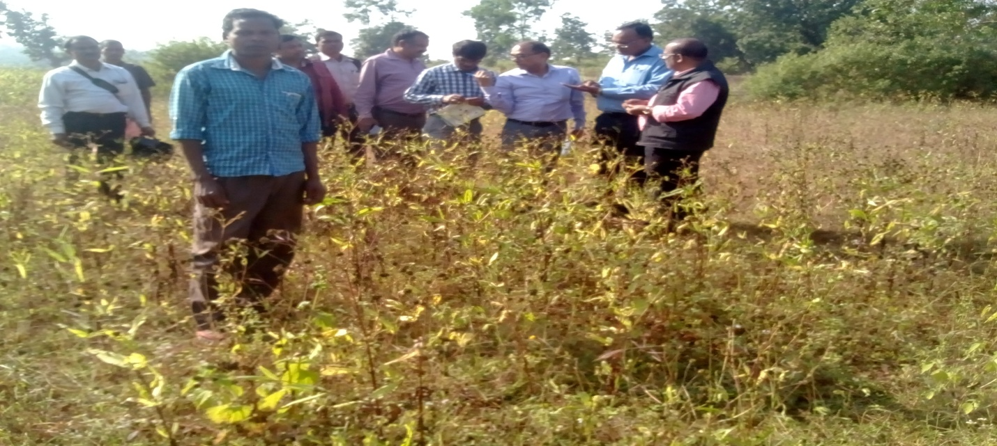
Niger cultivation under wasteland – State Plan

6.3.5 Cluster demonstration by KVKs:

FLDs of oilseeds and pulses were initiated through KVKs from rabi 2015-16 under NMOOP and NFSM. The status of FLDs organized by KVK, Jaganathpur and West Singhbhum during 2015-16 and 2016-17 is given in Table-8:

Table-8: Details of FLDs of KVK

Crop | Area (in ha) | No. of farmers | Variety/input | Yield (kg/ha)
 |  |  |  | FLD | DAY
Rabi 2015-16
Chick pea | 15.0 | 37+161* | Jaki 9218+Bio-fertilizer | 1370 | 193
Linseed | 20.0 | 52+158* | Sharda+Bio fertilizer | 590 | 84
Kharif 2016
Black gram | 9.2 | 23+138* | PU-31+Bio-fertilizer & micro nutrients | 1331 | 627
Rabi 2016-17
Chick pea | 20.0 | Yet to be sown
Mustard | 30.0 | Yet to be sown
*Other farmers benefitted with the technologies through training and field visit.

An area of about 10 ha identified in village Khairpal, block Majhgaon for FLD of mustard and chick pea may be an excellent cluster for FLD/Seed Village proposed by the KVK. The paddy crop has been just harvested and the farmers have started field preparation for sowing of rabi crops with pre-sowing (paleva) irrigation. Adequate water in the reservoir is available for providing one pre and one post protective irrigation.

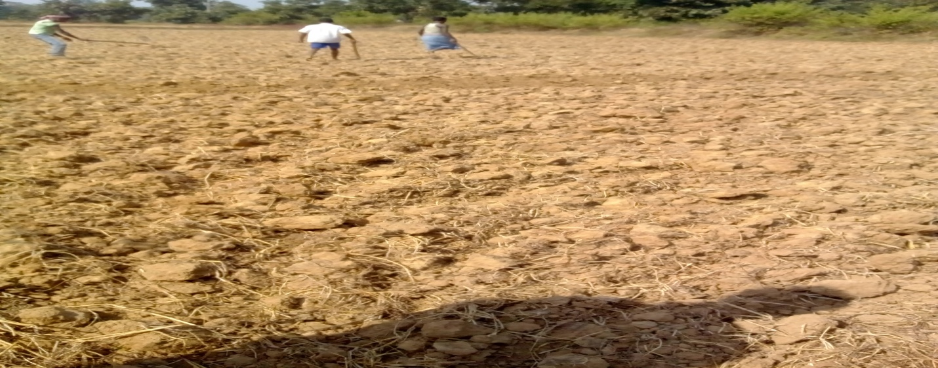
Field preparation of sowing of FLD on mustard in village Khairpal

6.3.6. Skill Development Prograqmme

A training programme for development of entrepreneurship in rural youths with a focus on soil testing was in progress at KVK, Jagannathpur, which has similar objective with PMKVY. Thirteen participants, who were either matric or 10+2, were present in the Lab. After completion of their training they could start their soil testing lab along with supply of agricultural inputs including micro-nutrients with an investment of Rs. <2 lakhs.

6.3.7 Supply of farm implements

Fifteenth November was the foundation day of the State. On this occasion the activities of the various Departments were displayed in the exhibitions organized at state and district level. The activities of Agriculture Department includes launching of Rabi Campaign Rath with display of schemes and initiatives available for the farmers under various schemes and supply of farm implements by the Agriculture Minister of the State to the farmers in Krishi Bhawan, Ranchi. The details of the farmers beneficiaries who were present their and received the farm implements under BGREI/NFSM is given below in Table-9.

Table-9 : Details of farmers beneficiaries of farm implements/machineries
Details of Farmers | Name of Implement/ Machinery | Cost of Machine (Rs.) | Subsidy (50%)
Smt. Panwa Devi, Vill. Paika | Pump Set (2 hp) | 17,200 | 8,600
Sh. Vinesh Mehto, Vill. Angara | Pump Set (2 hp) | 17,200 | 8,600
Sh. Ghasi Urao, Vill. Angara | Pump Set (2 hp) | 17,200 | 8,600
Sh. Charo Urao, Vill. Chano block | Pump Set (2 hp) | 17,200 | 8,600
Sh. Suresh Mehto, Vill. Lali Kohinar Tolli | Mini Rice Mill with diesel engine | 75,000 | 37,500
Sh. Shankar Das Goswami, Vill Badam | Mini Rice Mill with diesel engine | 75,000 | 37,500
Beneficiaries were not available | Manual Paddy Threshers | 5,800 | 2,900
 | Battery operated power sprayers | 5450 | 2725

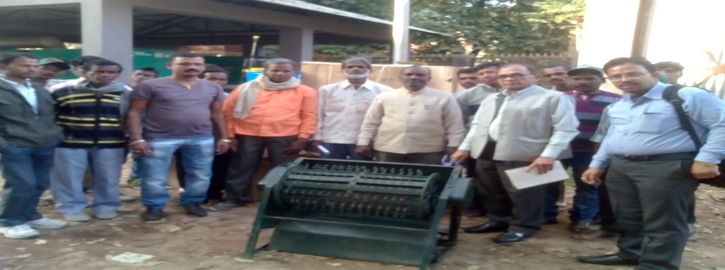
Manual paddy thresher being supplied under BGREI/NFSM-Rice

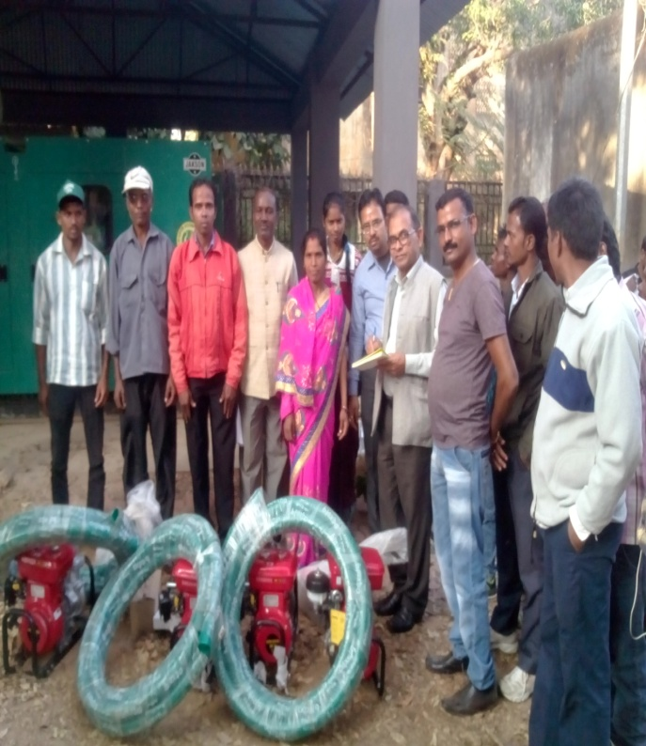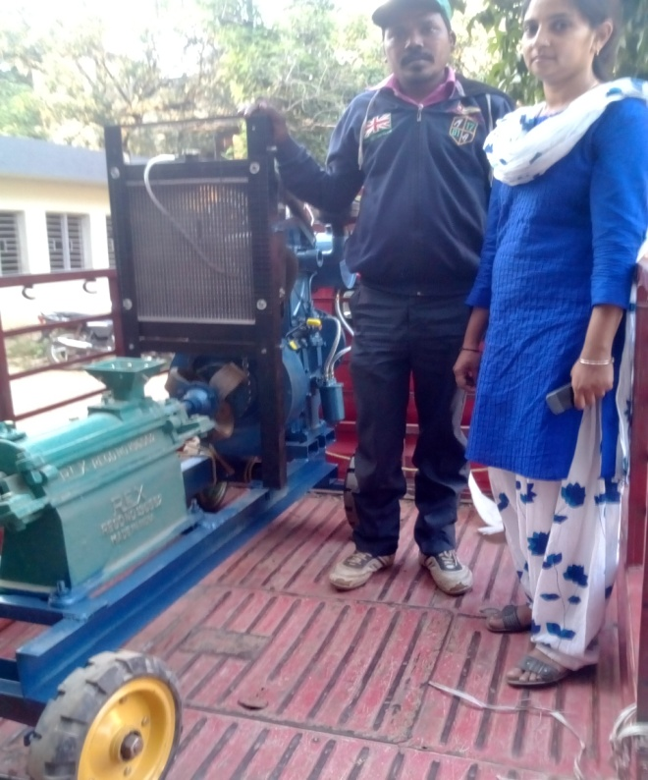
Supply of pump sets and rice mill under BGREI/NFSM-Rice
The State Government has made provision for supply of zero seed drills with 100% subsidy for utilization of rice fallows. The supply of these seed drills was awaited in the district. It was observed that zero seed drill may not be very effective tool in clay soils which have large share in the district. Use of rotavater would be more effective in faster seed bed preparation in such areas. It was informed that rotavaters are also being supplied in the district under NFMS rice and NFSM pulses.

6.3.7. Fund flow mechanism:

Fund for Centrally Sponsored Schemes including RKVY is released from DAC&FW to State Governments. Thereafter, funds from the State Treasuries are being drawn and incurred through SAMETI at State Level and ATAMA at District Level. The system appears to be more pragmatic. In case of farm implements distributed on 15th Nov., 2016, the cost of farmers share was collected by the suppliers/dealers and subsidy part will be reimbursed to them by DAO through cheques after verification of papers etc.. The discussions held with DAO and PD, ATMA, West Singhbhum also indicates that use of DBT has not been enforced so far in the state. However, under a new scheme launched by the state for encouraging use of rice fallow areas for rabi crop, an assistance of Rs. 1800/- per ha will be reimbursed through DBT to the farmers beneficiary after verifications/authentications of their fields.

7. New innovations:

The following innovative steps have been taken by the State Government for encouraging utilization of rice fallows areas for cultivation of rabi crop particularly pulses and oilseeds:

7.1. Supply of zero seed drill on 100% assistance

7.2. Assistance of Rs. 1800/- per ha through DBT to the farmers beneficiary after verifications/authentications for utilization of rice fallow areas for cultivation of rabi crops.

7.3. Creation of water harvesting structures/dobas (about 2 lakhs) on massive scale for harvesting of rainy water and its utilization for rabi crops.

8. Convergence

Good convergence was observed between NMAET, MNREGA, RKVY, State plan KVKS etc. for creation of water bodies, capacity building of farmers and transfer of technology

9. Market arrival and price situation:

State is lagging behind in creation of marketing infrastructure. However, Primary Agricultural Cooperative Societies (PACS) Large size Adivasi Multipurpose Societies (LAMPS) are involved in supply of input and also procurements of food grains through Cooperative/ Food & Civil Supplies Department.

10. Progress of implementation

All the component of NFSM except wheat, NMOOP and BGREI, a sub-scheme of RKVY are under implementation in Jharkhand State. A new sub-scheme of RKVY entitled, “Targetting Rice Fallow Area for cultivation of pulses and oilseeds” has also been launched in 02 districts namely Ranchi and West Singhbhum from Rabi 2016-17. Efforts are being made by the State for creating mass awareness about these schemes including State Plan activities through Media and Publicity. Rabi Campaign Rath launched on 15th November with Posters , pamphlets and field staff were seen both at State H?eadquarter on 15th November and on 17th November in rural areas of district West Singhbhum. A Nukkad Natak played by the District Agriculture Department on 15th November, available at nukkkad.westsinghbhum.youtube was also shared during the visit. Copies of the MPR for the month ending October, 2016 are at Annexure-III except MPR of NFSM pulses, which has already been passed on SO, CA-II to expedite the pending release of the State. As per these MPR the progress of implementation of all the component of NFSM and BGREI is satisfactory. However, progress of NMOOP is slow. The scheme-wise status of fund utilization is at Annexure-IV. However, status of scheme-wise allocation, release and expenditure is summarized in Table-10.
Table-10. Scheme-wise details of allocation, releases and expenditure during 2016-17:
(Rs. in lakhs)
Scheme | Approved allocation (CS) | UB as on 1st April, 2016 | Release (CS) | Expenditure
 |  |  |  | Central share | State share
NFSM rice | 992.87 | 53.62 | 496.43 | 426.02 | 204.45
NFSM pulses | 2809.50 | 150.24 | 00 | 668.17 | 445.57
NFSM CC | 170.40 | 00 | 85.20 | 50.31. | 45.25
BGREI | 4555.52 | 1361.00 | 2840.00 | 2167.50 | 1445.05
NMOOP | 381.00 | 37.46 | 127.00 | 12.33 | 8.48

During the state level discussions, it was informed that the state share has already been released in respect of all the above mentioned schemes. A copy of the sanction letter dated 18th July, 2016 conveying the sanction of the BGREI is at Annexure-V. A revised statement indicating the availability of unspent balance of Rs. 159.97 lakh of A3P of 2013-14 sought by Director (Crops) vide his letter dated 9th Nov., 2016 has also been furnished by the state. A copy of the statement has already passed on to SI-CA-II to facilitate the release of Central share under NFSM pulses. A copy of the same is also at Annexure-VI. The State Government has requested for release of central share in respect of NFSM pulses and issue of revalidation in respect of both NFSM and NMOOP. The copies of the communications issued by the state to Crop Division are at Annexure-VII.

11. Significant achievements / Initiatives

  - Record production of Kharif food grains of about 59 lakh tonnes as against the earlier highest production of 53 lakhs tonnes of Kharif food grains during Kharif 2011.

11.2 Enthusiastic action plan for bringing additional area of 3 lakh ha of rice fallow under Rabi pulses (>1.50 lakh ha) and Oilseeds (>1.50 lakh ha) during Rabi 2016-17.

11.3 Supply of seed drill with 100% subsidy, assistance of Rs.1800/ha. and construction of dobas on massive scales (about 2 lakhs) are the encouraging steps taken by the State for encouraging use of rice fallows for Rabi crops.

  - Strong linkage between State Department of Agriculture and SAU with a significant contribution in large scale seed production, transfer of technologies through FLDs and deployment of Scientist of BAU/KVKs as Project Director, ATMA in 04 districts.
  - Release of state share well in time (July, 2016) for all the schemes.

12. Constraints / Actionable points

12.1 Weak Staff Strength both at State and District level including KVK is a major constraint in implementation of development programmes, which could be resolved by engagement of contractual manpower under various schemes. (Action: State Government).

  - Seven self propelled reapers and one multi crop thresher supplied to KVK by the State Government are lying ideal from last two years. These may be allocated to interested FIGs/AC&BC/Entrepreneurs for running on custom hiring basis. (Action: State Government).

  - Proposal for age relaxation of varieties of pulses and oilseeds particularly for the districts covered under TRFA, a sub- scheme of RKVY may be considered by DAC & FW (Action: Oilseeds/ Crop Division)

  - Atleast 75% of approved Central share of Rs. 28.09 crore i.e. Rs. 21.00 crore may be to the state under NFSM-Pulses to supplement the efforts of the State Government in bringing addl. area of 1.5 lakh ha under pulses during rabi 2016-17. (Action: Crop Division)

  - Revalidation of unspent balances of NFSM and of NMOOP for utilization during 2016-17 may also be issued by DAC&FW. (Action: Oilseeds/Crop Division)
**********

