REPORT OF NATIONAL LEVEL MONITORING TEAM (NLMT) ON ITS VISIT TO UP FOR MONITORING OF NMOOP

First visit of NLMT-IV comprising the following members was undertaken in UP from 15th to 17th December, 2014 for monitoring of the progress of NMOOP and prospects of Rabi Oilseeds:

  - Dr. Dhiraj Singh, Director, DR&MR, ICAR, Bharatpur – Member
  - Dr. Subhash Chandra, Joint Director, DMD, Jaipur – Member
  - Sh. Ashok Kumar, Joint Director Agriculture (Pulses), Government of UP – Member
  - Dr. J. P. Singh, National Consultant, NMOOP – Coordinator.

2. Out of above 04 members, last 02 members assembled at Lucknow on 15th December, 2014 (morning) and remaining 02 join the team at Agra on 15th December, 2014 (evening). The activities reviewed/covered by NLMT are summarized as under:

Date | Activity | Location
15.12.2014 | State level review | Lucknow
15.12.2014 | Departure from Lucknow and halt at Agra | Agra
16.12.2014 | Meetings with all Stakeholders, | Office of JDA(Agra)
16.12.2014 | Visit to R&D Farms of Krishna Seed | Etmadpur, Agra
16.12.2014 | Block Demonstration of NMOOP | Maghtai, Bichpuri, Agra
16.12.2014 | Oil extraction units | Bichpuri
16.12.2014 | Departure from Agra and halt at Bharatpur | DRMR, Bharatpur
17.12.2014 | Varietal demonstration (Technology park) | DRMR, Bharatpur
17.12.2014 | Famer participatory seed production of DRMR | Awar, Bharatpur
17.12.2014 | Seed production farm of DRMR | Madhuri Kund Farm, Mathura
17.12.2014 | Cluster demonstration and FFS on IPM | Charora
17.12.2014 | Seed minikit plot | Seeh
17.12.2014 | Foundation seed production programme | State Government Farm, Charora

3. JDA, Agra Division remained available on both the days with the NLMT and organized meeting of all stakeholders including dozen of farmers in his office at Agra on 16th December, 2014. However, Dy. Director Agriculture, Agra and Mathura, who were either on leave or engaged in other task, could not join the NLMT. Field visit in Mathura district were arranged by SDAO, Sadar Mathura and DAO, Mathura.

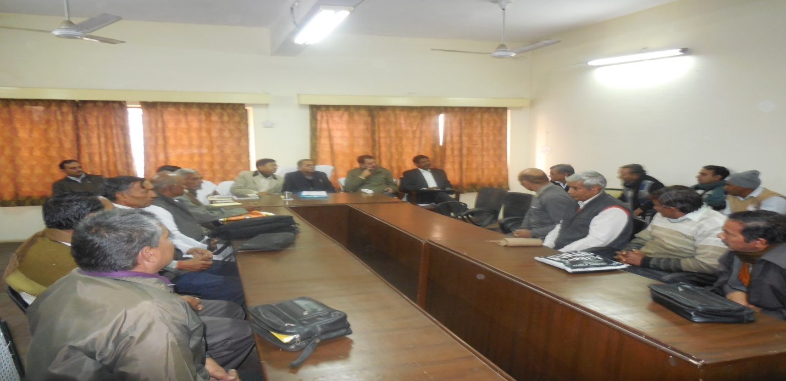
Interaction of NLMT with field functionaries and progressive farmers

4. Based on the discussions held with the Officers of Department of Agriculture, other Line Departments like Seeds & Farms, State Seed Corporation, R&D Farms, Oil Extraction Units and the Farmers, the observations and recommendations of NLMT are summarized as under:

4.1 Crop conditions and prospects:

Rapeseed & mustard is a major rabi oilseed crop in the State. The area coverage and production trend of the districts covered by NLMT and State, as a whole is given below:
(Area in 000ha , Production in 000tonnes and Yield in kg/ha)

District/State | Avg. of 3 years (2008-11) |  |  | 2013-14 |  |  | 2014-15
 | A | P | Y | A | P | Y | Area
Agra | 44.99 | 78.49 | 1745 | 53.14 | 76.09 | 1432 | 63.64
Mathura | 56.99 | 90.06 | 1580 | 43.33 | 65.79 | 1518 | 47.75
State | 700.17 | 796.97 | 1138 | 662.62 | 671.71 | 1014 | 744.38

The crop, which was largely sown between 10th October to 25th October, in both the districts of Agra and Mathura was at flowering to fruiting stage and free from any insects (Aphid) or diseases (Alternaria/white rust) so far except heavy infestation of aphid in the experimentation block of Krishna Seed Farm in Agra. Poor plant population was also observed where crop was sown in last week of September (either due to heavy temperature or (due to high salinity). Over all crop condition of mustard was excellent in both the districts and production at par with last year is expected. During the discussion with the field functionaries and the farmers, it was observed that toria is not cultivated in Agra district, whereas, an area coverage of >10000 ha has been reported in Agra Mandal by the State. This need to be looked into.

4.2 Progress of implementation

4.2.1 District wise action plan along with Hindi translations of Operational Guidelines of NMOOP was circulated on 26th June, 2014, immediately after the approval of AAP by DAC on 18th June, 2014, to all districts and agencies involved in implementation of NMOOP. The following discrepancies are noted in the Guidelines circulated by the State:

  - Para 5 of the Guidelines issued by the State envisage the size of cluster of 10 ha as against the size of 50 ha prescribed by DAC. Necessary corrections may be carried out by the State in their Guidelines.

  - The provision for supply of all types of pipes (HDPE and PVC etc.) has been restricted to only HDPE pipes under Para 18 of the Guidelines issued by the State. In district Agra and Mathura, more use of PVC pipes was observed.

4.2.2 A letter has already been issued on 11th December, 2014 by State Mission Director to all the districts to submit their AAP for 2015-16.

4.2.3 During the discussion, it was informed that the list of beneficiaries in respect of farm machinery including micro-irrigation system and water carrying pipes is decided by a Committee headed by CDO/DM. The beneficiary farmers are being registered with Aadhar number under Pardarshi Krishak Yojana (Biometric). Except seeds no other inputs is being supplied to the farmers in kind. The subsidy part of other inputs is being transferred to the bank account of the beneficiary farmers through RTGS against their bills/vouchers.

4.2.4 Each Sr. Technical Officers of State Headquarter like JDA/ADA have been assigned a Division for regular (monthly) monitoring of various schemes/programme. The problem noted during their field visit are either resolve in the field or reported to the Director Agriculture for necessary follow up by the concerned line department.

4.2.5 Division, crop and variety wise seed allocation for Rabi oilseeds circulated by the State on 5th August, 2014 includes age old varieties like T-9, Bhawani and PT-303 of toria and Varuna, Pusa Bold, Rohini and Narendra Rai of mustard released during late 70s and 80s. Therefore, despite an achievement of >80% under certified seed distribution, the savings may be >80% under seed component due to supply of seeds of old varieties.

4.2.6 As against the target of 13080 minikits of mustard, 12200 minikits were supplied by NSC at Agra between 12th–20th October, 2014, whereas, sowing of mustard already commenced by 10th October, 2014. NSC may be asked to explain the reason of delay.

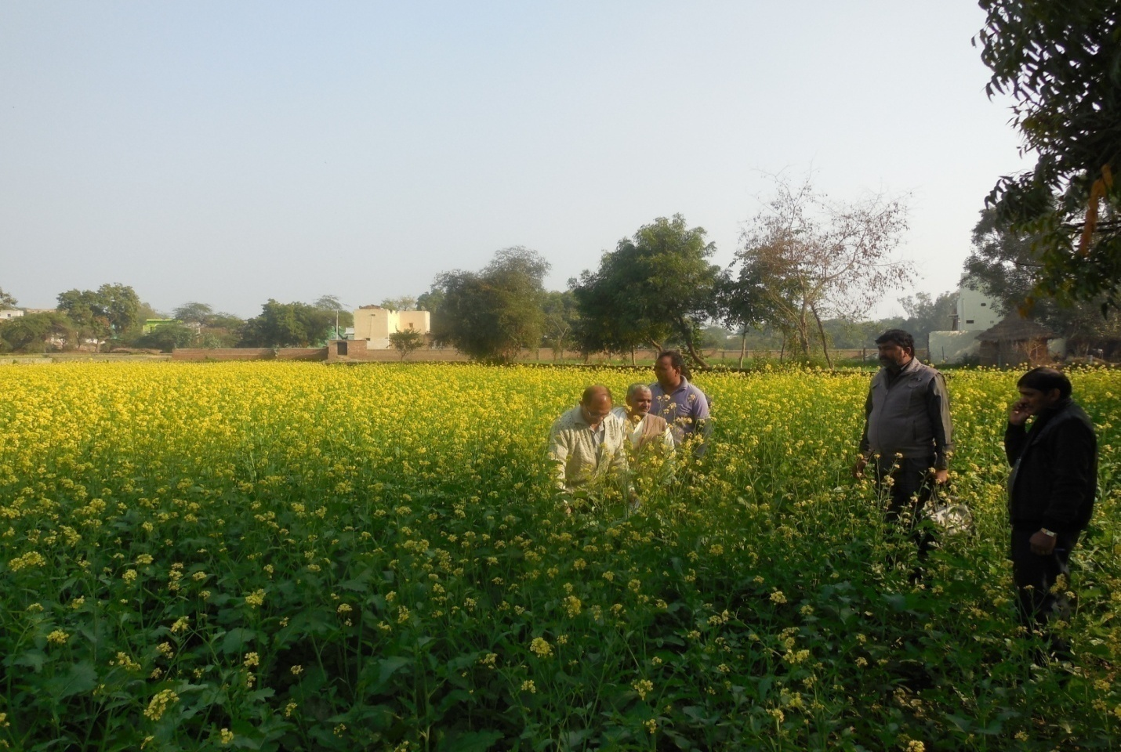
Seed minikits of CS-56 in village Seeh, Mathura

4.2.7 Field functionaries were not aware about the subsidy of Rs. 500 / ha on supply of SSP under NMOOP. They have also requested for supply of SSP through Government or Semi-Government Stores.

4.2.8 Shortage of urea was reported by the farmers in both the districts.

4.2.9 The beneficiary farmers of demonstration were supplied only seeds of old variety Rohini (1986) in district Agra and variety Pusa-27 (2011) in district of Mathura. Other inputs were purchased by the farmers. District wise list of farmers, whose plots were seen by the NLMT is given at Annexure-I. Rohini is a predominant mustard variety of Agra Mandal. The demonstration plot of Rohini were at flowering stage, whereas, demonstration plots of Pusa-27 in Mathura district, were at seed filling stage. Therefore, the crop will easily escape the disease/pest and also frost. The farmers were well convinced that Pusa – 27 can replace the Rohini variety of mustard.
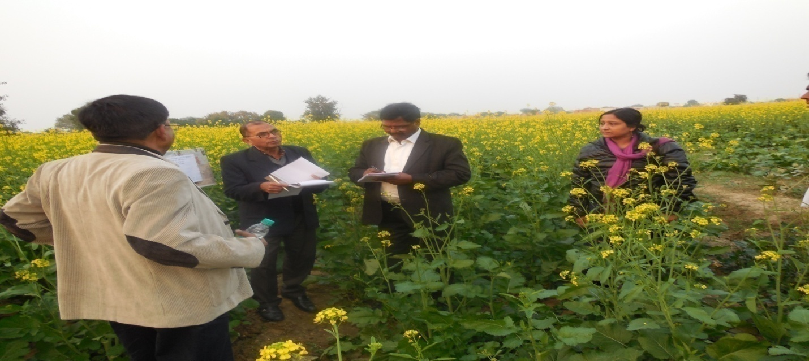
Block Demonstration with variety Rohni in village Maghtai, Agra
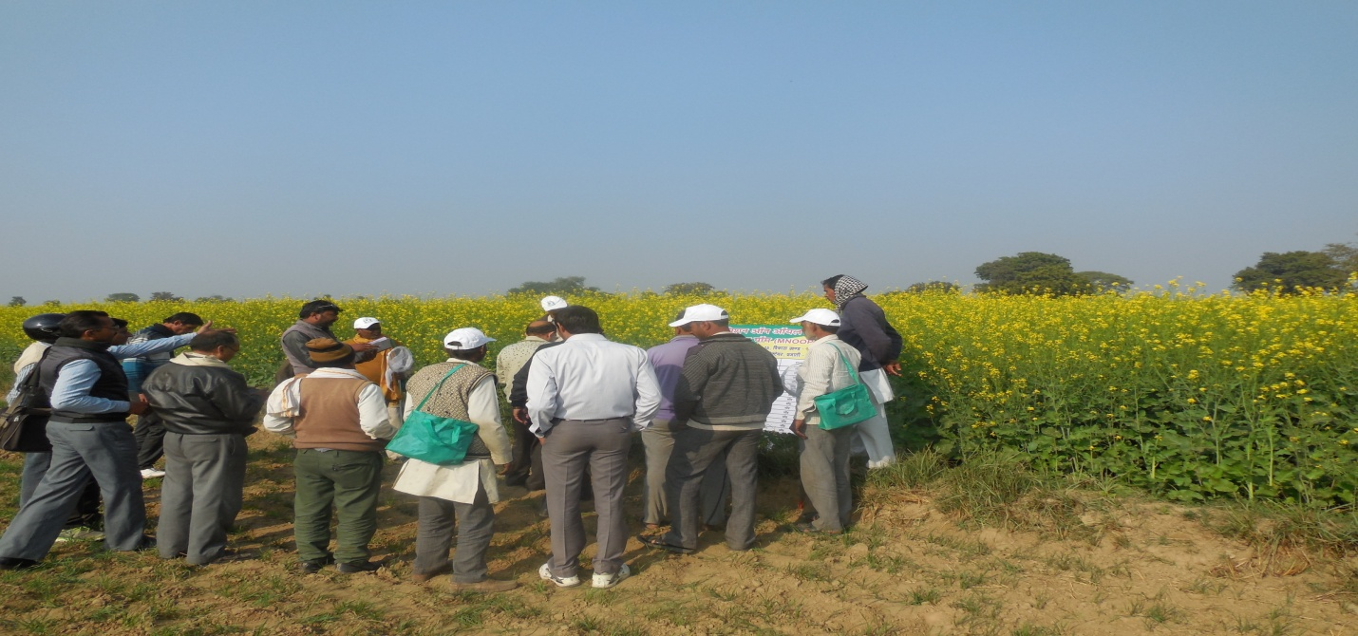 Block Demonstration with variety PM-27 in village Seeh, Mathura

4.2.10 The component wise progress of implementation of MM-I in Agra and Mathura districts and also State level progress is given at Annexure-II. Larger saving of >Rs.50 lakhs is expected under seed component. The progress under demonstration, farm implements including PP equipments and farmers training is by and large satisfactory. However, due to low subsidy and clarity at the field level the progress under water carrying pipes was slow. The farmers in both the districts have shown more interest in purchase of PP equipments and water carrying pipes. Therefore, it was suggested that the requirement of these components may be worked out and proposal for diversion of savings from seeds and other components to PP equipments and water carrying pipes may be considered by the State Government.

4.2.11 Financial progress as on 9th December, 2014 given in Annexure-II indicates an average utilization of 40% with highest average utilization of 62% in Chitrakut Division followed by Agra Division (53%) and lowest of 13% in Gorakhpur and 23% in Lucknow (Annexure-III). Therefore, the progress of implementation, need to be monitored more closely by the State. JDA farmers have invariably.

5. The following steps taken by Directorate of Rapeseed & Mustard Research (DR&MR), Bharatpur, State Department of Agriculture and State Seeds Corporation are worth encouraging as far as replacement of old varieties are concerned:

5.1 DR&MR, Bharatpur

Organized massive seed production programme of new varieties of mustard over an area of 80 ha. The following seed plots were visited:

5.1.1 Seed production programme of NRDR-2 organised over an area of 12 ha and RH-749 over an area of 35 ha at Madhuri Kund Farm of Pt. Deen Dayal Animal & Vetenary Science University, Mathura through an MoU signed between Director, DRMR, ICAR and VC of the University. Despite, high pH of >9, good crop of mustard has been raised. Homogenous plant growth, flowering indicates purity of varieties. After harvesting/processing/grading seed will be sold to the farmers by DR&MR during seed pakhwada to be arranged from 15th to 30th September, 2014 on first come first serve basis.

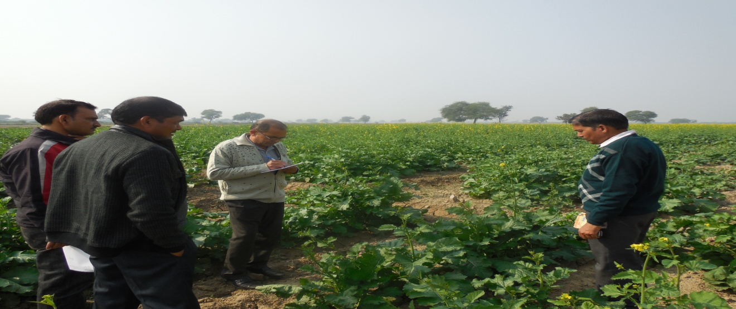
Seed production of variety RH 749 by DR&MR at Madhuri Kund Farm, Mathura
5.1.2 Farmer participatory seed production of NRCHB-101 over an area of 14 ha in village Awar, Bharatpur. These seed growers will be paid with a pre-announce price (highest price in the local APMC with 10 % hike) for the quantity of graded seed. The under sized produced is returned to the farmers by DR&MR. The seed will be sold by the DR& MR directly to the farmers @ Rs.65/- per kg during seed pakhwada.

5.1.3 In addition to varietal yield trial, demonstration of 25 released varieties of mustard has been laid out in Technology park of DR&MR. The crop was at full flowering stage and will be at fully developed pod stage after mid of January.

5.1.4 Requirement of training-cum-Exposure visit of field functionaries and progressive farmers of UP was also discussed and it was decided that Government of UP will sponsor name of field functionaries and farmers for two (02) slots each of three (03) days to be organized in 2nd half of January, 2015. DR&MR has accommodation for both Officers and farmers.

5.1.5 DR&MR is willing to host a National Mustard Mela/ Meet in 2nd fortnight of January, 2015 (19th – 21st February) for the benefit of major mustard growing States like Gujarat, Haryana, MP, Rajasthan and UP and selected farmers/Officers from other States like Assam, Bihar, Chhattisgarh and J&K. Cost of travel of the participants may be met from ATMA funds and cost of organizing Mela including visit of participants to seed production plots, which are far away from Bharatpur, may be supported from NMOOP.

5.2 State Department of Agriculture

Organized foundation seed production of a new variety Pusa – 28 (released in 2012) over an area of 11.60 ha at Chharora, Govt. Seed Farm, Mathura. This is an early maturing variety of mustard. The crop sown on 12.10.2014 was at pod formation stage. This variety shows an excellent / escaping from both biotic (Aphid/Alternaria/white rust) and a-biotic (frost) stresses. This could replace toria particularly M-27 in Assam and Odisha. State Government may organize visit of farmers from neighboring districts to this seed farm.
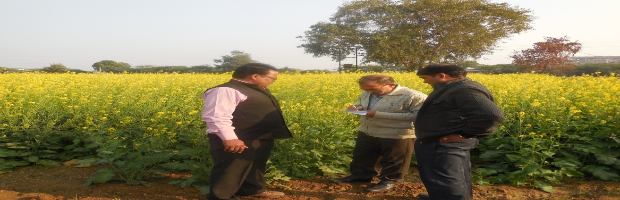
Foundation Seed production of PM-28 at Charora Farm, Mathura (State Government)
5.3 State Seed Corporation (SSC):
Organized foundation seed production of NRCHB-101 over an area of 2 ha on the Research farm of Agriculture College,, Bichpuri, Agra. However, NLMT could not visit the plot due to paucity of time.

6 Krishna Seed Farm

Seed Company established in 1989 is engaged in development of varieties/hybrids of mustard, wheat and pearl millet. Company has a good infrastructure for seed production and processing at their farm located in village Etmadpur, Agra. Genetic variability developed by Seed Company indicates the following positive features:

6.1 Early maturing mustard genotype with 90-100 days duration could help in replacement of toria varieties and utilization of paddy fallows.
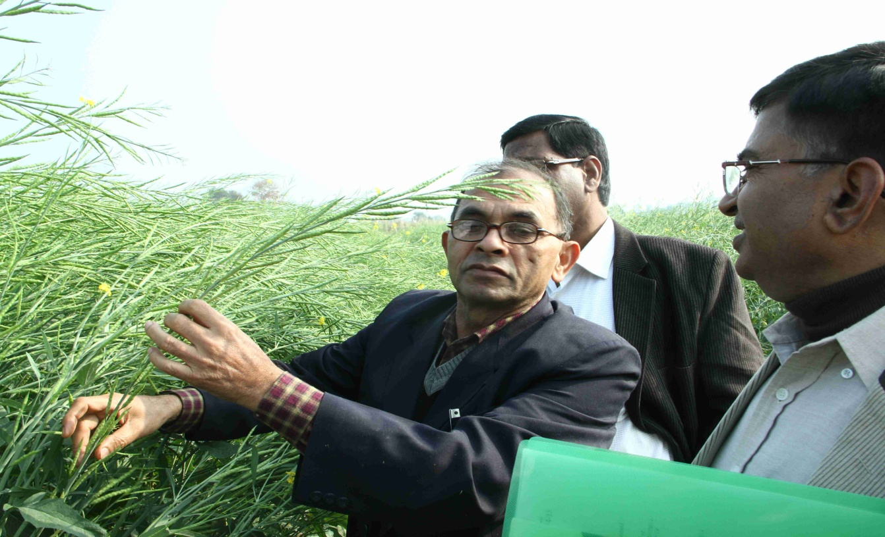
Genotypes of Indian mustard with early maturity (90-100 days)

6.2 High yielding genotypes with medium duration of 120-135 days with long fruiting branches with more pod per plant will help in productivity improvement.

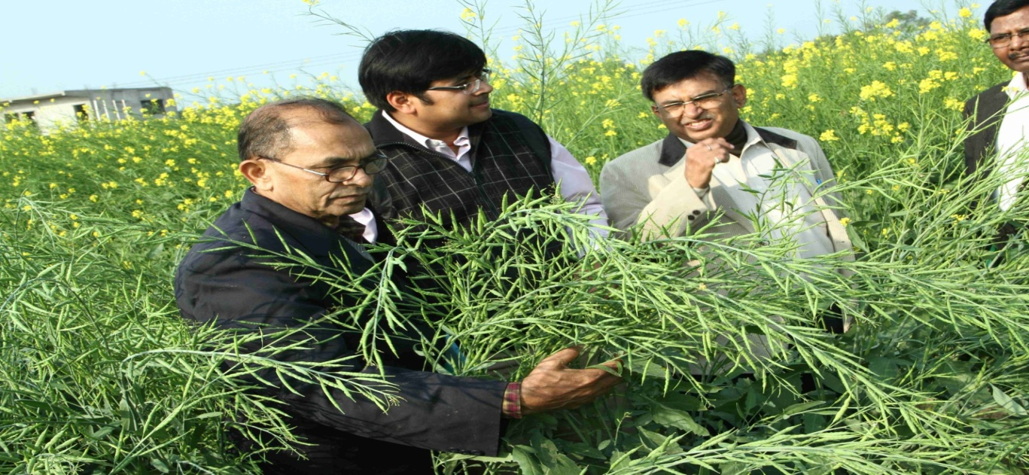
High yielding material with medium maturity (120-135 days)

6.3 Distinct earliness in hybrids of Indian mustard and stable restorer lines.
6.4 Good high yielding erect and compact plant type for inter-cropping.

6.5 The company is selling about 500 qtl. seeds of Indian mustard annually in Agra Mandal. Farmers have reported good performance of seed purchase from the company.

6.6 Heavy infestation of aphid was observed in some of the plots.

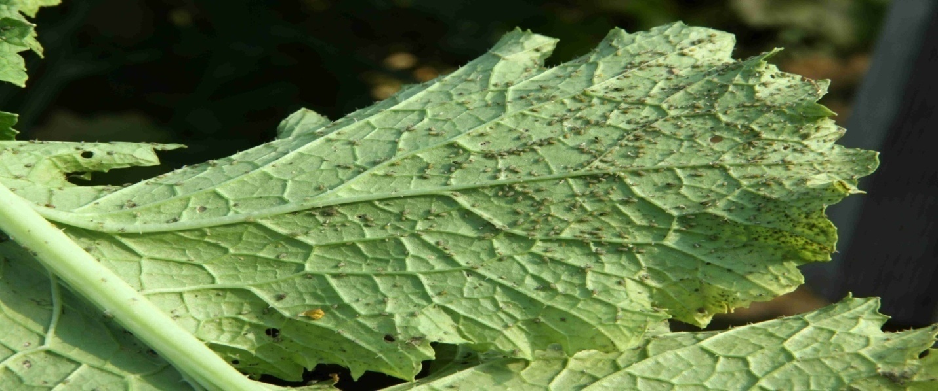
Infestation of aphid in Indian mustard

7. Oil Extraction
Discussions held with 02 oil extraction units with a capacity each of 100-150 MT mustard seeds per year located near Bichpuri Railway Crossing, Agra reveals that entire oil cake, which contains 5-8% oil is purchased either by farmers or animal feed retailers and they were not aware about any Solvent Extraction Unit, who can buy their cakes for extraction of oil. The situation may be more verse in remote areas, which are beyond the reach of SEP. Therefore, necessary efforts may be made to make an assessment of such oil losses and taking steps for utilization of such vegetable oils.

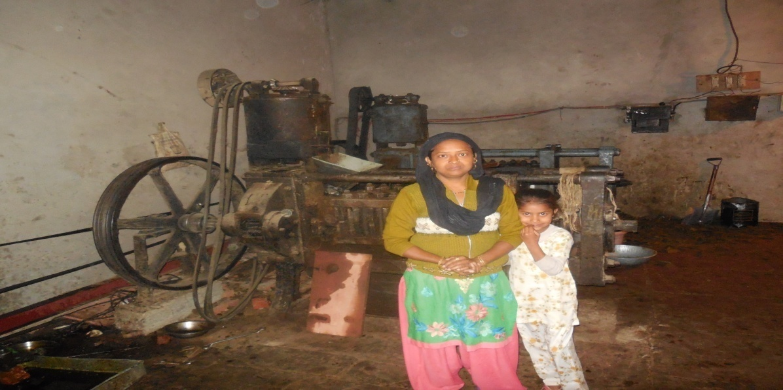
Oil extraction unit near Bichpuri Railway Crossing, Agra

8 Recommendations:

8.1 As mentioned under para 4.2.1 necessary corrections may be carried out in the Guidelines of NMOOP circulated by the State. (Action: SDA, UP)

8.2 Estimates of area coverage of toria may be re-visited, and corrections may be carried out, if any. (Action: SDA, UP).

8.3 An early decision may be taken by the State for diversion of savings from seeds and other components to PP equipment and water carrying pipes. (Action: SDA, UP)

8.4 SMS alert may be issued immediately for monitoring of pest (aphid) and their control measures. (Action: SDA, UP)

8.5 Necessary clarifications/instructions may be issued to field functionaries about the provision of subsidy of Rs.500/- per ha on supply of SSP under NMOOP and arrangement of supply of SSP through Government or Semi-Government Stores. (Action: SDA, UP)

8.6 Issue of nomination of field functionaries and progressive farmers to DR&MR, Bharatpur for organizing training-cum-exposure visit. (Action: SDA, UP)

8.7 Submission of proposal for organizing National Mustard Mela/Meet by DR & MR, Bharatpur. (Action: DR&MR, Bharatupur)

8.8 NSC may be requested to provide date wise delivery of seed minikits of mustard in various States and more particularly in respect of Agra Division of UP. (Action: Oil Seeds Division, DAC)

8.9 To expedite the study on “Assessment of oil losses through oil cakes and rice bran”. (Action: Oil Seeds Division, DAC)

Sd/- Sd/-
(Sh. Ashok Kumar) (Dr. Subhash Chandra)
JDA (Pulses) JDA, DMD

Sd/-
(Dr. Dhiraj Singh) (Dr. J. P. Singh)
Director, DR&MR National Consultant, NMOOP

Annexure-I

Details of farmer plots visited by NLMT

Name of Farmer | Village | Block | District | Stage and Crop condition
Block demonstration ( Variety-Rohani)
Smt Rajkumari w/o  Sh Ravindra | Maghtai | Bichpuri | Agra | Good crop at flowering stag without any infestation of disease/pest
Sh Krishan Kumar s/o Sh Harisankar | Maghtai | Bichpuri | Agra
Sh Birender Kumar s/o Sh Ramesh Chand | Maghtai | Bichpuri | Agra
Sh Ramesh Chand s/o Dal Chand | Maghtai | Bichpuri | Agra
Sh Ashok Kumar s/o Shri Sukumar | Maghtai | Bichpuri | Agra
Sh Sekhar Agrawal s/o Sh R. C. Agrawal | Maghtai | Bichpuri | Agra
Block demonstration ( Variety-Pusa-27)
Sh Vishnu Kumar s/o  Sh Tursiram | Seeh | Govardhan | Mathura | Good crop at pod formation stage without any infestation of disease/pest
Sh Kanyalal s/o Sh vanwarilal | Seeh | Govardhan | Mathura
Sh Shankarlal s/o  Sh Uday Ram | Seeh | Govardhan | Mathura
Sh Radheyshyam s/o  Sh Vasudev | Seeh | Govardhan | Mathura
Sh Chheetarmal s/o  Shi Dunda | Seeh | Govardhan | Mathura
Sh Radheysham s/o  Sh Ram Hari | Seeh | Govardhan | Mathura
Minikit (Variety-CS 56)
Sh Rab Bahadur s/o  Sh Vasudev Sharma | Seeh | Govardhan | Mathura

