Report of visit to Rajasthan to assess the ground situation of olive cultivation

A visit was made to Rajasthan by Dr. M. Dutta, Consultant (Oilseeds), DAC from 8-10 June, 2015 to assess the ground situation of olive cultivation in the state. A brief meeting was held with Dr. S.P. Sharma, Addl. Director, Agriculture and Director, State Institute of Agriculture Management at Jaipur in which official of Rajasthan Olive Cultivation Limited (ROCL) was also present. It was informed that Rajasthan Govt. is planning to organize an International Conference on Olive involving all stakeholders to promote olive cultivation in the country. As reported by ROCL, olive plantation has been taken up at 7 farms mainly in the north-western districts of the state covering an area of 182.0 ha (Tables 1&2). Besides, about 124.0 ha area is under private olive cultivation.
Table 1. Details of olive growing farms in Rajasthan

S. No. | Name of Farm | District | Area (ha)
1 | Barore | Sri Ganga Nagar | 30
2 | Bakalia | Nagaur | 30
3 | Lunkaransar | Bikaner | 30
4 | Santhu | Jalore | 30
5 | Basbisna | Jhunjhunu | 30
6 | Tinkirudi | Alwar | 30
7 | Bassi | Jaipur | 02
Total |  |  | 182

Table 2. Olive plant population at various farms in Rajasthan as on 31 March, 2015
Variety | Barore | Bakalia | Lunkaransar | Santhu | Basbisna | Tinkirudi | Bassi | Total
Barnea | 5796 | 8408 | 7673 | 4619 | 6744 | 5951 | 1087 | 32325
Picual | 1053 | 220 | 783 | 215 | 965 | 0 | 63 | 2932
Picholine | 1103 | 1151 | 1263 | 607 | 1582 | 691 | 92 | 6583
Arbequina | 952 | 1565 | 1620 | 682 | 1643 | 1570 | 364 | 7829
Cortina | 794 | 851 | 836 | 707 | 1104 | 2656 | 0 | 6977
Frontoio | 549 | 220 | 380 | 900 | 524 | 398 | 92 | 3530
Korinoiky | 1060 | 540 | 1184 | 536 | 1401 | 433 | 437 | 5621
Total | 11307 | 12955 | 13739 | 8266 | 13963 | 11699 | 2135 | 65797

8th June, 2015

A visit was made to Bassi Farm, 36 km away from Jaipur where Govt. of Rajasthan has established a Centre of Excellence in Agriculture in an area of 208 ha. ROCL has been allotted 70.0 ha area of which about 2.0 ha has been put under hi-tech polycarbonate condition. About 2.0 lakh olive seedlings of 1 year old, grown from stem cuttings are being maintained in the greenhouses while 1.0 lakh seedlings have been sold. The seedlings are raised on special trays with 28 cuvettes filled with soil, sand and pits. The greenhouses are computer controlled for fertigation, mist, temperature etc. The seedlings are supported with special iron sticks coated with plastic. Technical guidance for managing the nursery is obtained from UDITECH, Israel. The cost of one seedling is about Rs. 115.00.
Olive plantation in the orchard was undertaken during 2008 in about 2.0 ha area. Among the varieties, Korinoiky showed sparse fruiting in about 50% of the plants. Variety Picholine did not show any fruiting yet. In addition to olive, ROCL is undertaking cultivation of other high value crops such as sugar yielding plant, Stevia and high energy exotic plant like Tamerix erecta from Israel.
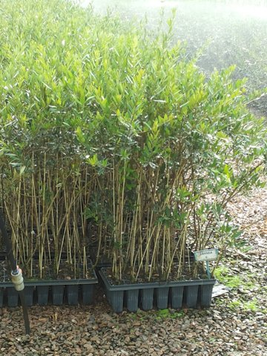
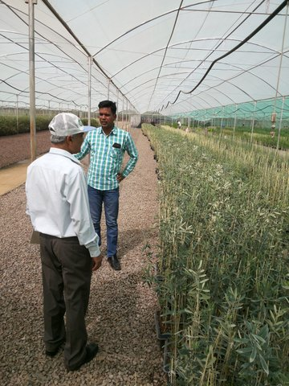

Hi-tech olive nursery at Bassi, Jaipur

9th June, 2015

A visit was made to a private olive farm in about 1.0 ha area near village Nawa, district Nagaur. The EC of the irrigation water at the farm was more than 11.0. The plantation was 1 year and 5 months old and was healthy except for mortality of 2-3 plants due to some unspecified infection at the collar region. This was followed by a visit to the farm at Bakalia, district Nagaur. In addition to the officials of ROCL (Chief Operating Officer, Asstt. Director and Senior Farm Manager), Asstt. Director and AAO, Department of Agriculture were present during the visit. The farm has about 30.0 ha in which about 13000 olive plants of approx. 5 years old has been raised. Out of 7 varieties planted, 5 were in fruiting; variety Arbequina was in 3rd year fruiting while other 4 varieties were in 2nd year fruiting.
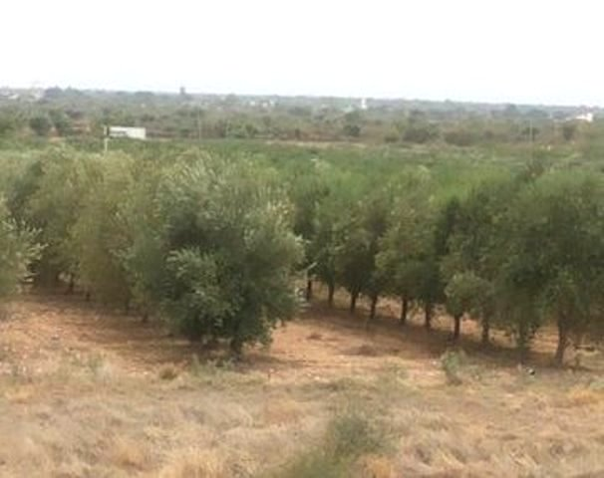
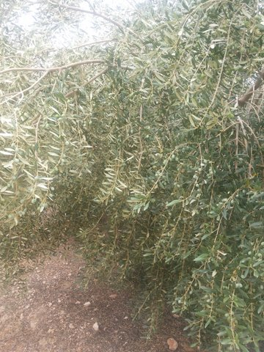

Olive orchard at Bakalia, Nagaur

In variety Arbequina all the plants were in fruiting while in variety Barnea 75% plants were in fruiting. The fruit yield in Arbequina was estimated to be 15-20 kg/tree which could reach up to 25-30 kg/tree at maturity. The variety Korinoiky that possesses highest oil percentage (18%) had 10-15 kg fruits per tree and could reach up to 20-25 kg/tree at maturity.
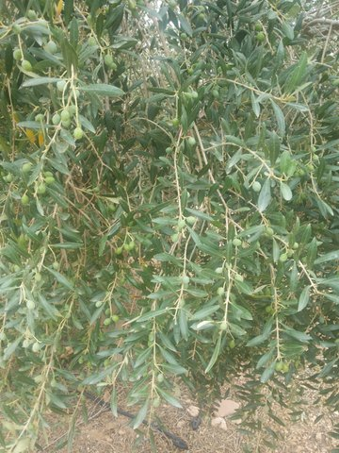
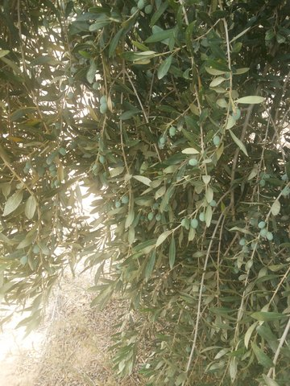

Olive branches in fruiting

Variety Picholine was in the first year fruiting and had about 5-8 kg fruits per tree while the variety, Cortina had about 5-6 kg fruits per tree. Among the varieties Arbequina showed highest promise. The trees were quite healthy except for a fungal complex caused bark splitting in a few trees.

10th June, 2015

A visit was made to the farm at Poogle, district Sri Ganga Nagar, near Indo-Pak border where about 7.25 ha area has been put under olive plantation during January, 2015. Arbequina, Korinoiky and Picholine were the major varieties having 3461 plants. The plantation has been established on sand dunes with drip irrigation from the stored water received once in a month through the Indira Gandhi Canal.
Next visit was made to the farm at Barore, district Sri Ganga Nagar. The farm produced highest fruit yield among all the 7 farms during 2014 but in the current year it has been affected by hailstorm in April-May when the trees were in bloom. The soil of the farm is clayey and has water stagnation at a few spots during high rainfall resulting in mortality of a few plants. Fruiting was observed in 50% of the trees. The fruit yield of the trees ranged from 1-10 kg per tree with variety Barnea showing best performance.

Visit to Lunkaransar farm located about 70 km away from Bikaner was made where besides olive plantation an olive expeller plant has been commissioned during October, 2014, inaugurated by the Chief Minister of Rajasthan. The expeller procured from M/s Amenduni, Italy at a cost of about 2.70 crores has a capacity of 5 tons per hour, which can be raised further with addition of chambers (Malexers). A cold storage facility is being constructed for storing of fruits before processing. The farm has about 30.0 ha area in which about 14000 olive plants have been raised. Among the varieties, Korinoiky showed highest fruiting estimated to be 15-20 kg/tree followed by Barnea (10-15 kg/tree), Arbequina (8-10 kg/tree), Picholine (6-8 kg/tree) and Cortina (4-5 kg/tree). Some trees in which vegetative growth was the maximum and kept aside for experimental purposes showed negligible fruit bearing.

Salient observations and recommendations:

- As reported by ROCL, the fruit production during 2014 was about 120.0 tons from which 8.0 tons of oil was extracted and sold at a wholesale price of Rs. 360/- per lit. But during the current year approx. 50-60 tons of fruits are expected to be produced.
- Among the farms visited, Bakalia showed best performance in terms of fruiting followed by Lunkaransar, while at Bassi fruiting was negligible. Although varietal performance varied from location to location, varieties Arbequina, Barnea and Korinoiky were the best performers.
- On an average 10-12 kg fruits per tree are estimated to be harvested at maturity from the fruited trees with the highest fruit yield reaching up to 25-30 kg per tree. With an estimated 400 trees per ha, having average yield of 7.0 kg per tree and 15% oil recovery approx. Rs. 1.05 lakh per ha income is expected @ Rs. 250 per lit of oil. Green fruits could also be sold in bottles/packs after treating with brine solutions @ Rs. 20.0-25.0 per kg. However, unfruitfulness in a few varieties and some trees across varieties is a concern and needs in-depth investigation.
- Rajasthan Govt. has declared North-Western part of the state as the ‘olive hub’ but a strong coordination between ROCL, State Department, SAU and ICAR institutes located in the state is required to make it a success.
- At present, indigenous technical backup is a major bottleneck hindering further promotion of olive in the state. Technical back-stopping is the need of the hour with an identified institute dedicated to olive research.
- Manual harvesting of fruits is costly, time consuming and labour intensive resulting in poor quality of fruits and oil. Therefore, mechanical mode of harvesting needs to be explored.
- High initial investment coupled with long gestation period (3-5 years), are the issues that need consideration while deciding target groups and scaling up the programme.
- The success of olive even in salt affected areas shows its promise as a horticultural crop in the north-western part of Rajasthan. However, with daily requirement of about 40 lit. water per tree, olive should be planted in areas with adequate micro-irrigation (drip) facility as water supply is strongly correlated with better fruiting.
- Although, ROCL is a company but it still works under the same restrictive norms of a public organization, which is reducing its effectiveness. Frequent change of personnel also causes knowledge gap and reduces focus.
- More support is required in terms of financial and human resources to make olive cultivation a success. The district officials and farmers need to be further sensitized about the NMOOP guidelines and support available under the Mission.

As per the current assessment of the ground situation of olive cultivation in Rajasthan, there is scope for promotion of olive in North-Western part of the State.

(Dr. M. Dutta)
Consultant (Oilseeds)

