Package of Practices (PoP) of Soybean (Glycine max-Linn)
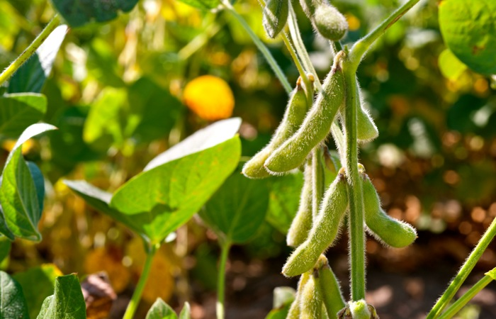
- Soil and seed bed preparation: - Soybean can be grown under wide range of soils with better performance under Vertisols rich in organic carbon. Deep ploughing once in 03 year is recommended for moisture conservation and insect-pest management.

- Sowing time: - Optimum sowing time is from mid of June to end of June subject to availability of moisture/rainfall.

- Varieties:- Selection of varieties may be made on the basis of time of rainfall. Multiple varieties may be adopted instead of single variety.

- Seed treatment:- Application of Rhizobium (400 gm per 65-75 Kg seed), Phosphorus Solubilizing Bacteria (PSB) and Fungicide (Thiram + Carbendazim) or Trichoderma viridi @ 8-10 g/kg of seed.

- Seed rate: - Optimum seed rate of 55-65 kg/ha with a spacing of 30-45 cm, which could be reduced with the use of broad-bed-furrow/ridge-furrow.

- Inter cropping:- Inter-cropping of arhar with soybean for risk management

- Nutrient Management: - Recommended dose of 25: 60: 40:30 N: P: K: S Kg / ha in north plains zones, application of 5kg Zn/ha through zinc sulphate is recommended.

- Weed Management:- Application of pre emergence weedicides (Pendamethalin / Metolachlor/ Diclosulum) followed by inter-culture operations.

- Water Management:- Adoption of Broad-Bed-Furrow/Ridge-Furrow System for effective water management. Life saving irrigation at pod initiation and grain filling . Spray of anti-transparent like KNO₃ @1% or MgCO₃ or Glycerol is also recommended during long dry spell.

- Pest and Disease Management:- In addition to deep summer ploughing and seed treatment, use of resistant varieties like JS 335, PK 262, NRC 12, MACS 124 against stem-fly, NRC 7, NRC 37, JS 80-21, Pusa 16, Pusa 20, Pusa 24, PS 564, PK 472 against defoliators, JS 71-05 against girdle beetle, JS 80-21, PK 1029, PK 1024, Indira Soya 9 against soybean rust, PK 262, PK 416, PK 472, PK 1042, NRC 37 against collar-rot, PK 416, PK 472, PS 564 against bacterial pustule, and PS 564, PK 1024, PK 1029, PS 1042, PS 1092, SL 295 against yellow mosaic virus are also recommended.

- Harvesting:- Timely harvesting of the crop, when pods turn pale yellow, is recommended to avoid shattering.

- Yield:- Rainfed condition – 1600-2000 kg/ha
Irrigated condition – 2000-2500 kg/ha

