Package of Practices (PoP) of Sesame (Sesamum indicum )
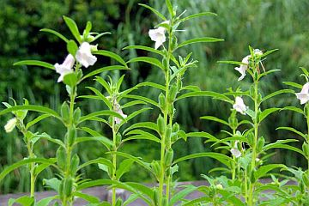
- Climate and soil:- The crop is grown in the plains and also at elevation up to 1200 m. It is grown in sandy-loam to heavy black soils.

- Sowing time:- Sesame is considered as a contingency crop and could be sown upto mid of August under delayed rainfalls during Kharif season. Rabi crops could be sown from Sep-Nov and Summer crop, which has largest area in WB is sown in Feb/March.

- Seed treatment:- For the prevention of seed borne diseases, seed may be treated with Bavistin @ 2 g/kg seed. Seed may be soaked for 30 minutes in 0.025% solution of Agrimycin-100 prior to seeding in the area of bacterial leaf sport disease.

- Seed rate:- A seed rate of 5 kg/ha is adequate to achieve the required plant population. In order to facilitate easy seeding and even distribution increase the bulk by mixing the seed with either sand or dry soil or well sieved farm yard manure in 1:20 ratio.

- Spacing:- 22.5 to 45 cm between rows and 10 to 22.5 cm between plants in the row

- Method of sowing:- Seed drills may be used for sowing in rows.

- Nutrient Management:- may be used as per soil health card. In areas deficient in sulphur, application of 15-30 kg S/ha is recommended at the time of sowing.

- Weed Management:- The crop is most sensitive to weed competition during the first 20-25 days. Two weeding, one after 15-20 days and 30-35 days after sowing are suggested

- Water Management:- Irrigation at flower initiation and capsule formation is essential.

- Pest and Diseases Management:- Use of resistant varieties is the most economic method of reducing the losses by pest and disease attack.

- Harvesting:- Crop should be harvested when leaves turn yell and start dropping while the capsules are still greenish-yellow.

- Yield:-
  - Kharif – 375-500 kg/ha
  - Rabi – 500-750 kg/ha
  - Rainfed condition – 500-600 kg/ha
  - Irrigated condition – 900-1000 kg/ha

