Package of Practices (PoP) of Safflower (Carthamus tinctorius L)
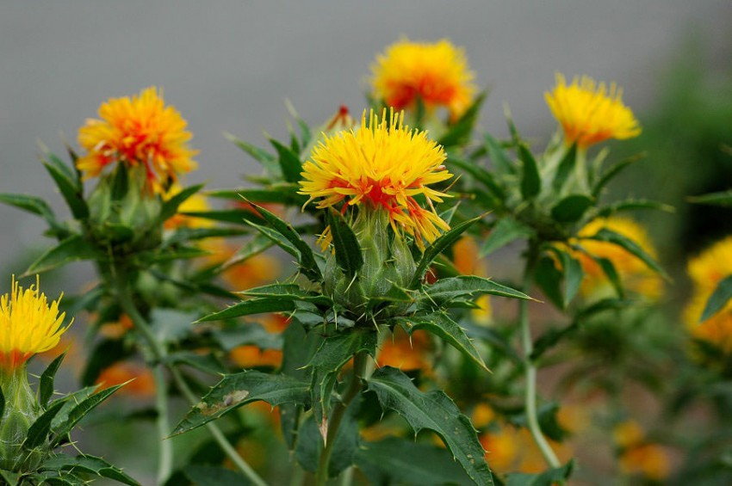
- Climate and soil:- Safflower comes up better in relatively drier areas. It requires fairly deep, moisture retentive and well drained soils. The crop is fairly tolerant to saline condition and grows well under residual moisture in paddy fallows.

- Sowing time:- Depending upon the availability of conserved/ residual moisture/late Kharif rains crop could be sown from late September to mid of November

- Seed treatment:- Seeds should be treated with Thiram, Captan or Carbendizim @ 3 g/kg seed before sowing.

- Seed rate:- Seed Rate of 7.5 kg to 20 kg / ha is used depending upon soil conditions

- Spacing:- 30cm x 15 cm or 45cm x 20 cm

- Method of sowing:- Follow line sowing using improved seed drills or fertilizer-cum-seed drills

- Nutrient Management:- Application of fertilizers may be made as per soil health card.

- Weed Management:- Normally, weeds do not pose any serious problem in safflower except when frequent rains are received during initial phase of crop growth or when land preparation and tillage are not proper. Timely weeding and interculture during rosette stage is crucial for arresting weeding and obtain full benefits.

- Water Management:- Yield can be boosted by 40 to 60% by providing just one life saving irrigation at critical stages of crop growth (early stem elongation or flowering).

- Pest and diseases Management:-
  - Safflower is affected by a number of insect pests and diseases. However, aphid is a major problem under late sown conditions.
  - Spray Dimethoate (0.05%) or Methyl Parathion (0.05%) or Monocrotophos (0.05%) or Chlorpyriphos or Endosulfan (0.05%) or alternatively dust Quinalphos (1.5%) or Methyl parathion (2. 5%) or Malathion (5%) or Endosulfan (4%) at 40 and 60 DAS.
  - Use 500 litres of spray mixture and 20 kg dust formulation/ha.
  - Spray Mancozeb (0.25%) immediately after disease is noticed and repeat the spray 15 days later depending on the intensity of Alternaria leaf spot.

- Harvesting:- The crop is ready for harvest when the leaves and most of the bracteoles become dry and brown. Hand gloves may be used to protect legs and hands against spines. Effect of spines could also be minimized by harvesting of crop before rising of sun. Multi-crop threshers and combine harvester could be used for harvesting and threshing.

- Yield:-
- Scanty moisture condition – 800 – 1200 kg/ha
- Favourable moisture condition - 1500 – 2000 kg/ha
- Minimal irrigation – 2000 – 2800 kg/ha

