Package of Practices (PoP) of Rapeseed -Mustard (Brassicas)
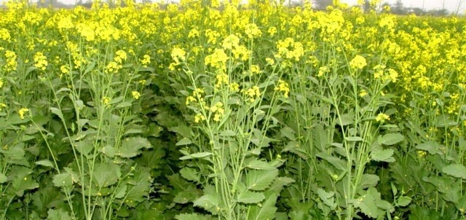
- Soil:- The crop require longer cool temperature. Mustard could be successfully grown under wide range of soils including saline/alkaline, low irrigated and paddy fallows in Eastern India.

- Sowing time:- An average day and night temperature of 25⁰ C is considered optimum for sowing. From August end to first half of September is best for sowing of toria, 25th September to 15th October for sarson, 30th September to 15th October for mustard.

- Seed treatment:- Seed treatment with Apron SD 35 @ 6 g/kg of seed is advised for White Rust and Downy Mildew endemic areas. For other seedling diseases, seed treatment with Carbendazim, Thiram or Captan @ 2 g/kg of seed is recommended.

- Seed rate:- 4-5 kg/ha.

- Method of sowing:- Line sowing with row-to-row distance of 30 cm and plant-to-plant distance of 10-15 cm. Use of ridge-furrow technique is beneficial in saline areas. Thinning is necessary after three weeks of sowing for maintaining optimum plant population.

- Nutrient Management:- Integrated nutrient management with 40 kg N per ha for rainfed situations and 40-80 kg of N per ha under irrigated situations is recommended.

- Weed Management:- Clean cultivation with regular weeding.

- Water Management:-
- Two irrigation for mustard one at 20-30 days after sowing (DAS) and another at siliqua formation stage (50-60 DAS)

- Use of ridge & furrow technique is beneficial in saline area and for moisture conservation.

- Pest and Diseases Management:-
- Aphid, painted bug, alternaria, white rust and powdery mildew are the major insect/ pest of rapeseed-mustard crop.
- Seed treatment with Carbedazim 0.1% or Thiophanate Methyl against seedling diseases and imidacloprid @ 5g/kg of seeds.
- Use of ridomil MZ 72 WP @ 3g/l for control of white rust and spray of Mancozeb 50 WP @ 2g/l needs to be taken up at 50 and 70 days after sowing for control of alternaria.
- Dusting of Sulphur @ 1.5 kg/ha or spraying of Sulfex 2 g/l for powderymildew
- Spray of systemic insecticides viz. Monocrotophos, Oxydemeton Methyl etc., for control of aphid.

- Harvesting:- Harvesting as soon as the crop begins to turn yellow, threshing mechanically and storing at the moisture content of less than 8% is suggested.

- Yield:-
- Rainfed condition – 800-1500 kg/ha
- Irrigated condition – 2000-2500 kg/ha

