Package of Practices (PoP) of Niger (Guizotia abyssinica)
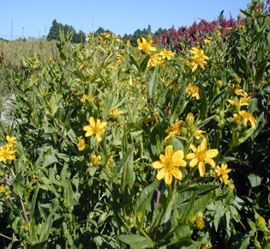
- Soil:- Niger could be raised in wide range of soils from clay loam to sandy loam, sandy and gravel soil. It can withstand slight alkalinity and salinity also.

- Sowing time:- Primarily, Niger is a Kharif crop, but mostly sown in late July/ August.

- Seed treatment:- Seed should be treated with Thiram or Captan 3.0 g/kg seed before sowing. Seed treatment with Phosphorus solubilising bacteria (PSB) 10 g/kg seed gives higher yield.

- Seed rate:- Generally 5 kg/ha seed is required for the sole crop. Line sowing has been found beneficial with spacing of 30cm x 10cm.

- Method of sowing:- The crop is largely sown by broadcasting. Seeds are mixed with sand/ powdered FYM/ ash to increase the bulk, 20 times to ensure even distribution of seed.

- Nutrient Management:- The crop is mostly grown on marginal and sub-marginal land without manure or fertilizer application. However, application of recommended N through urea + seed treatment with PSB 10 g/kg seed enhances yield significantly. Application of sulphur (20-30 kg/ha) increases seed yield and oil content in niger.

- Weed Management:-
- First weeding is needed 15-20 days after sowing. In Orissa, Cuscuta (Cuscuta hyalina/ C. chinensis) infestation has become a major problem. Seed should be obtained from Cuscuta free areas. Cuscuta seeds could be separated with a 1 mm sieve.
- Pre sowing soil application of Fluchloralin (1 kg a.i./ha). or Pre emergence application of Pendimethalin (1.5 kg a.i./ha).

- Water Management:- It is invariably grown in the rainy season and it is seldom irrigated. There are indications that niger yields can be doubled under irrigation, it the crop suffers from moisture stress. Irrigation may be given at the seedling stage.

- Pest and diseases Management:- Niger is generally not menaced by any major insects ot diseases.

- Harvesting:- Niger usually matures in 95-105 days after sowing. The crop should be harvested when the leaves dry up and the capitula turns brownish / blackish in colour.

- Yield:-
- Pure crop – 400-500 kg/ha
- Intercrop – 150-300 kg/ha

