Package of Practices (PoP) of Linseed (Linum usitatissimum)

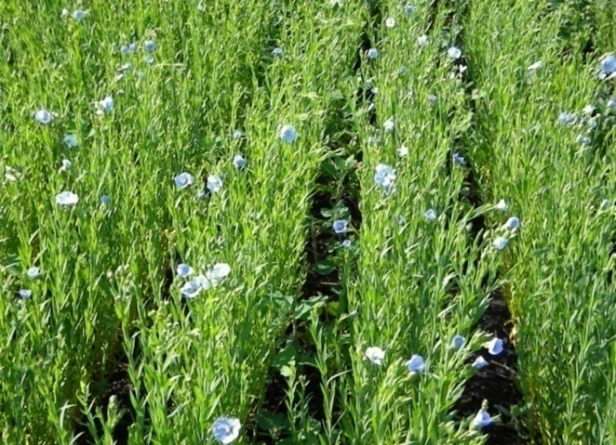
- Climate and soil:- Linseed is a cool season crop and requires moderate to cool temperature. It is grown best in well drained, fertile, medium and heavy soils especially silty loam, clay loam and silty clays. This crop is under cultivation in three ecosystems namely utera, rainfed and irrigated. Growing linseed in utera system is the predominant practice in Eastern States under paddy fallows.

- Sowing time:- The crop could be sown during October to first fortnight of November depending upon the soil moisture and irrigation facilities.

- Seed rate:- High seed rate ranging between 25 to 30 kg/ha is used under different situation.

- Spacing:- A row spacing of 20-30 cm with a plant to plant spacing of 7-10 cm is ideal.

- Method of sowing:- Drilling in prepared seed bed or by broadcasting in the standard rice crop as utera.

- Nutrient Management:- Application of fertilizer @ 40 kg N + 20kg P₂O₅ and 20kg/ha K₂O has been found quite beneficial in increasing yield of this crop in rainfed eco-system at various locations. Higher doses of fertilizers are used for dual purpose (seed + fibre).

- Weed Management:- To ensure clean cultivation, cuscuta seeds should be separated before sowing. Other weeds could be managed by post emergence application of weedicides isoproturon @1.00kg/ha at 30-35 DAS. However, 2,4-D (Na) @0.5kg/ha may also be mixed in the tank with Isoproturon if broad leaf weeds are also problem.

- Water Management:- Yields can be doubled with 1 or 2 irrigations given at 35 and 75 DAS. On light soils, 3-4 irrigations may be needed. Branching, flowering and grain filling are critical stages for irrigation.
- Pest and diseases Management:-
- Two fortnightly sprays of spinosad 45 SC (0.015%) reduces upto 78% bud fly infestation, which enhances upto 63% seed yield.
- Two application of neem based commercial formulation containing Azadirachtin 300 ppm reduces upto 63% bud infestation and thereby enhancement upto 40% in seed yield.

- Harvesting:-Crop should be harvested by sickle when the leaves are dry, the capsules have turned brown and seeds become shiny

- Yield:-
- Rainfed condition – 800-1000 kg/ha
- Irrigated condition – 1600-2000 kg/ha
- Protective irrigated condition – 1200-1500 kg/ha

