Office of Joint Secretary (OS)
Room No 297 D, Krishi Bhawan
S.  No | Name | Designation | Address | Contact Number | E-Mail | Photo
1 | Dr. B. Rajender | Join Secretary (OS) | M-21 -5B Nivedita Kunj, Sector 10 . R.K.Puram | 011-23381176  9599428809 | b.rajender@ias.nic.in | 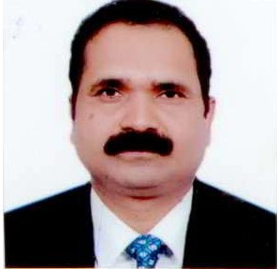
2 | S. Jayasree | PPS to  JS (OS) | 103F, Pocket-IV  Mayur Vihar  Phase-I  Delhi-110091 | 9711123632 | sayahree1961@gmail.com | 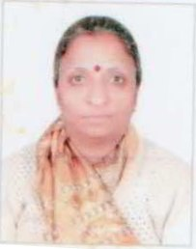
3 | R.N. Bansal | PA to JS(OS) | C5/110A  Keshavpuram  Lawrence Road  Delhi-110035 | 011-23381176  9810863107 | rnbansal64@gmail.com | 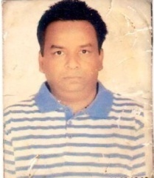

Office of Additional Commissioner (OS)
Room No 37 B, Krishi Bhawan
S.  No | Name | Designation | Address | Contact Number | E-Mail | Photo
1 | Dr. Anupam Barik | Additional Commissioner | H.No.K-16,Andrews Ganj Extension  New Delhi | 9968452420  011-23384618  Ext.4963 | adcoilseeds-agri@gov.in | 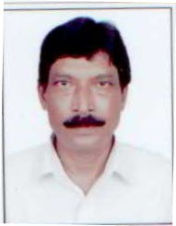
2 | VACANT | PS
3 | Mrs. Girija. T | Technical Assistant | 3014-5, 2nd floor, Gali No. 16, Ranjeet Nagar, West Delhi-110008 | 7760459397 | thippeswamygirija@gmail.com | 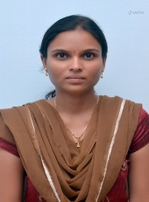

Office of Director (OS)
Room No 17, Shastri Bhawan
S.  No | Name | Designation | Address | Contact Number | E-Mail | Photo
1 | VACANT | Director |  | 011-23382021  Ext.2371
2 | Sobhana S Pillai | PS to  Director (OS) | 768 Sector-D  Mandir marg  Goal Market  New delhi-110001 | 9968142025 | pillaisobhana@yahoo.in | 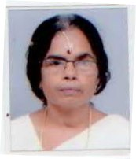

Oilseed unit
Room No.542-A, Krishi Bhawan

S. No | Name | Designation | Address | Contact  Number | E-mail | Photo
1 | Sh. Jitendra Kumar | Assistant Director | K-983  Sector-9  Vijay Nagar  Gaziabad | 011-23070617  9873479059  Extn:4517 | jitendra.kumar22@gov.in  jkumar.ud@gmail.com | 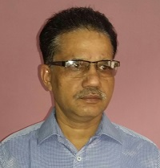
2 | Smt. Arya Lekshmi. V | Senior Technical Assistant | YWCA Working Womens Hostel  Jaisingh Road  New Delhi-1 | 9495605898 | arya.lakshmi@gov.in  aryalekshmi@gmail.com | 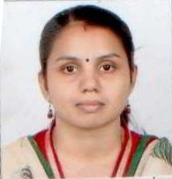
3 | Sh. M. R. Meena | Senior Secretariat Assistant | RJF 462  Mahatma Gandhi Marg  Raj Nagar-2  Palam  New Delhi-45 | 9968271636 | mannurammeena@gov.in  mrmeena283@gmail.com
4 | Sh. Ramesh Kumar | Junior Secretariat Assistant | H.No.1168 Sector 31  Housing Board Colony  Gurgaon | 9868161168 | rameshkumar16466@gmail.com | 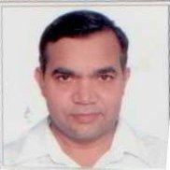
5 | Sh. Girish Kumar Pal | Staff Car Driver | H.No.1120-F, HBC, Sector-31  Gurgaon-122001 | 9868161194 | palgirish68@gmail.com | 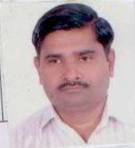

Central Agency Unit,
Room No.535, Krishi Bhawan

S.  No | Name | Designation | Address | Contact Number | Email/ Phone no. | Photo
1. | Sh. T.P. Singh | Assistant Commissioner | H.No. 1,  (Malati Kunj),  Ram Leela Ground, Near Hanuman Gate (no. 3),  Hapur-245101, UP | 011-23072130  Extn. No. 4535  9557410510 | tpsinghdac@gmail.com | 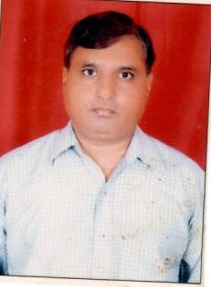
2. | Sh. Ashwani Kumar | Technical Assistant | H. No. 317-D,  Street No. 10,  Hardev puri, Shadhara,  New Delhi-110093 | 8010070026 | ashwanikumar340@gmail.com | 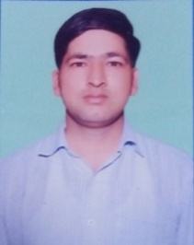
3. | Sh. Bhim Singh | Data Entry Operator | H. No. 11,  Bhim Gali, Bhagwan Nagar, Ashram,  New Delhi-110014 | 9013656407 | bhimsingh76@gmail.com | 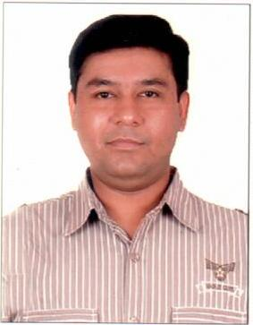
4. | Smt. Neerawati | MTS | C-90,  East Jawahar Nagar, Loni Road, Ghaziabad,  Uttar Pradesh – 201102 | 9891857249 |  | 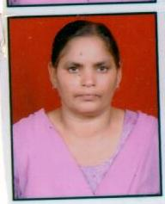

Oil Palm Unit,
Cabin No. 19, Shastri Bhawan

S. No | Name | Designation | Address | Contact Number | E-mail | Photo
1. | Sh. Ranvir Singh | Assistant  Director | H. No. 1618, Sector-55, Faridabad | 011-23071024  9650982105  Extn. No. 5519 | ranvir.singh27@ gov.in | 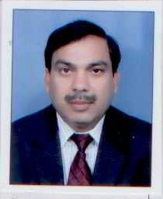
2. | VACANT | Assistant
3. | Sh. Tilak Raj | Senior Secretariat Assistant | 64/62, Sector-3, R.K. Ashram Marg, New Delhi-110001 | 9868229168 | tilakrajarora@hotmail.com | 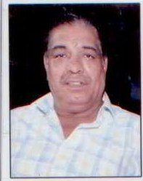
4. | Sh. Dalip Kumar | Senior Secretariat Assistant | Q. No. 97 H, Sector-4, Pushp Vihar, New Delhi-110017 | 9013292758 | dalip.kumar18@ gov.in | 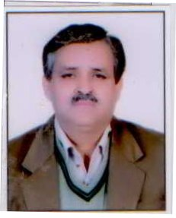
5. | Sh. Amar Singh | Technical Assistant | WZ-85, Todapur, New Delhi-110012 | 9868598337 | amar.singh30@gov.in | 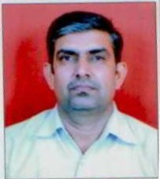
6. | Mrs. Lisha Kalra | Data Entry Operator | H.No. 2H-30 (Back Side), N.I.T. Faridabad-121001 | 9650619998 | lishasatija@yahoo.in | 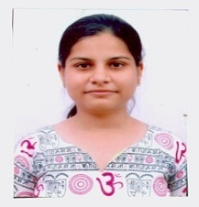

TBOs/Coordination Unit
Cabin No.3, Shastri Bhawan

S. No | Name | Designation | Address | Contact  Number | E-mail | Photo
1 | Sh. Jajna Narayan Padhy | Assistant Director | H.No.492,  Lane 8, Jyoti Park  Gurgaon-122001 | 011-23382011  9312106706  Extn.5503 | jnpadhy@yahoo.in | 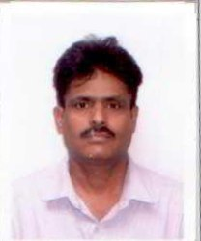
2 | Ms. Niharika Shukla | Technical Assistant | 2674/3, Shadipur  Main Market,  New Delhi-110008 | 9958279665 | niharikas86@gmail.com | 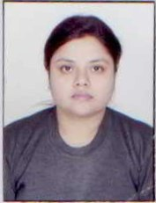
3 | Sh. Ashutosh Pandey | Technical Assistant | D-1/159,  Mahavir Enclave, Gali No.7  Palam  New Delhi-110045 | 9868859435 | aashutoshpandey@yahoo.co.in | 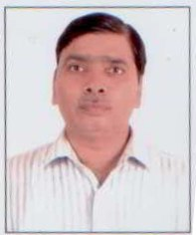
4 | Sh. Om Prakash | MTS | F-323, SL-III  Sector 57  Gurgaon-122002 | 9868155011 |  | 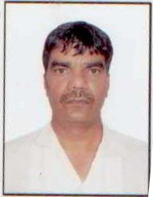

Crop Administration-II Unit
Room No.541, Krishi Bhawan

S. No | Name | Designation | Address | Contact Number | Email | Photo
 | Ms. Madhu Handa | Section Officer | Quarter No. 13, Type – IV, Sector – X, R.K. Puram, New Delhi | 011-23382149  9810445231  Extn.4994 | madhu.handa@gov.in | 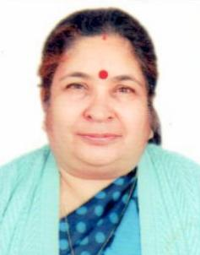
 | Sh. Mahesh Kumar Mathur | Assistant Section Officer | L-114/B, Sector – 9 New Vijay Nagar Ghaziabad (U.P.) | 9868737550 | maheshkumar.mathur@gov.in | 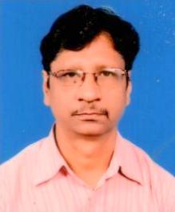
 | Sh. Dinesh Kumar | Data Entry Operator  (Non-Official) | N-16, Gali No. 1, Vijay Vihar, Uttam Nagar New Delhi | 9999723567 | soca541@gmail.com | 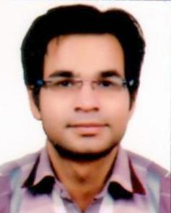

Crop Administration -VI Unit
Room No.480, Krishi Bhawan

S.  No | Name | Designation | Address | Contact Number | E-mail id | Photograph
1 | Sh. Pradeep Singh Negi | Section Officer | Flat No.108, SAMRAT Apartment, Vasundhara Enclave, Delhi-96 | 011-23385910  Extn No. 4480  8860327539 | pradeep singh.negi @ gov.in  pradeep singh negi 65 @ gmail.com | 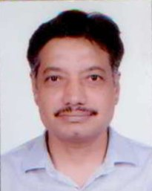
2 | Sh. Gan Pati Jha | LDC-cum-Typist | RZH-148, Rajnagar-II  Palam Colony, Street-5  New Delhi-110077 | 8587024819 | ganpatijha.1965@gmail.com
3 | Sh. Bhagwan Singh Yadav | JSA | Quarter No.78, Sector-9,  RK Puram, Delhi-22 | 23385910  9716536698 |  | 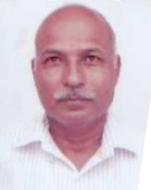

Administration & Coordination (Oilseeds)
Cabin No.14, Shastri Bhawan
S.  No | Name | Designation | Address | Contact Numbers | Email/Phone No.
1. | Sh. Kailash Choudhary | Under Secretary (OS) | B-6/296, Sector-7  Rohini, Delhi-110088 | 011-23071128  9968071368  Extn-5514 | kailash.c14@nic.in | 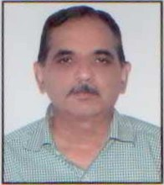
2. | Sh. Sukhpal Singh | Section officer (OS) | H.No.B-4/4 Balraj Nagar  Loni Road Ghaziabad | 011-23461601  8744978704  Extn-5512 | sukhpal.singh18@gov.in | 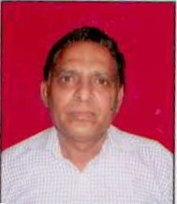
3. | Sh. S.R.  Kotiyal | Assistant Section Officer | Block C-II/14, 1st Floor Lodhi Colony | Extn- 5525  9013304537 | sr.kotiyal@gov.in | 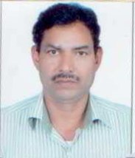
4. | Sh. Subhash Kumar | Sr. Secretariat officer | Road No. 3. H.No.91  AndrewsGanj New Delhi 110049 | 9999364491 | subhash.kumar38@gov.in | 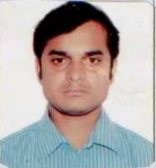
5. | Sh. Badley Singh | M.T.S | H.No.80/P, Sector-4 Pushp Vihar  Saket-MB,, Raod, New Delhi-110017 | 8860220747 | 19badelysingh65@gmail.com | 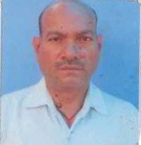
Data Processing Manager
Cabin No.18, Shastri Bhawan
1 | Sh. Mahesh Chander | Programmer | 2K-64  NIT  Faridabad | 23383476  9911105234 | maheshchander64@nic.in | 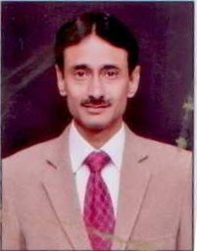

Technical Support Group (TSG Cell)
Cabin No 20, 21 Shastri Bhawan

S. No | Name | Designation | Address | Official address / Phone No. / | E-mail | Photo
1. | Dr. J.P. Singh | Consultant (Oilseeds) | Krishna Kunj, 1st Floor, Gali No. 24, Sadhnagar, Palam Colony, New Delhi-110045. | Extn. 5521  9650131044 | jpsingh_doe@yahoo.co.in | 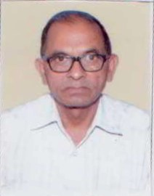
2. | Dr. M. Dutta | Consultant (Oilseeds) | RA-96, 3rd Floor, Inderpuri, New Delhi- 110012. | Extn. 5521  9873163544 | manoranjandutta@rediffmail.com | 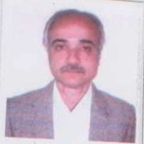
3. | Sh. S.K. Dalal | Consultant (Oilseeds) | B-3/99-C, Keshav Puram Lawrence Road, New Delhi-110035. | Extn. 1613  9868948715 | skdalal@gmail.com | 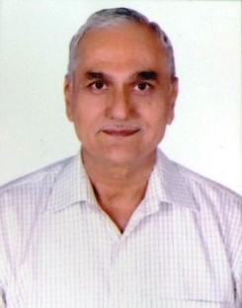
4. | Sh. Hariom Kumar | Steno Gr. ‘C’ | Vill. Khentawas PO Farrukh Nagar Distt. Gurgaon-122506 | 9582484852 | hariomkumar@hotmail.com | 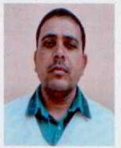
5. | Ms. Shabnam Parveen | DEO | 1128, Kishan Ganj, Teliwara, Delhi-110006 | 8527504807 | Shabnamkk86@gmail.com | 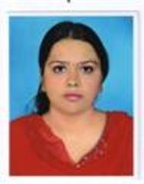
6. | Sh. Bapi Mukherjee | Technical Assistant | NBPGR Old Guest House ICAR-IARI Campus, PUSA, New Delhi | 9127059389 / 9647846878 | bapicob12@gmail.com

